Chapter 3: Evaluation of PBM-derived TF motif models for genomic scans

3.1 Introduction
In this chapter, I discuss the ultimate goal of building a complete dictionary of sequence binding preferences for all DNA-binding proteins to broaden our understanding of the how the specificity of protein-DNA interactions is mediated biophysically, and how this data can augment genomic regulatory sequence searches.

A major finding described in the previous chapter is the apparent lack of non-exonic sequence conservation associated with orthologous genes exhibiting conserved expression profiles across orthologous tissues, challenging our understanding of how the flexibility of cis-regulatory architecture and degree of binding site turnover contribute to the mechanisms underlying conservation of gene expression patterns. However, one intriguing possibility that cannot be fully eliminated is the divergence of TF binding specificity; despite the observation that individual monomeric TF sequence specificities seem to be largely unchanged from worms to flies to mammals (Berger et al. 2008; Noyes et al. 2008), one cannot preclude possibilities such as changes base-contacting residues altering the trans-regulatory architecture over evolutionary time. Moreover, the sparseness and paucity of comprehensive binding affinity measurements for the majority of TFs hinder our ability to draw any broad conclusions on whether the studied binding behaviours of TFs among different structural classes are the exception or the rule.

This chapter focuses on how my collaborators and I have leveraged the use of the PBM assay to glean insights into the binding specificities of TFs spanning different structural classes and organisms. The capacity of PBMs to rapidly survey TF affinities to all possible DNA sequence variants up to length k (k = 10 in current designs) has also introduced new challenges in the interpretation and representation of TF binding activities. I discuss the approaches I’ve taken to analyze, interpret and use this rich resource towards exploring the relationship between PBM-bound TF k-mers and genomic features. A main finding my colleagues and I made was the preference for multiple distinct motifs by many of the factors we studied and understanding the role of such alternate motifs in the context of TF function will be of great interest in future studies.

3.2 Results

3.2.1. Spectrum of binding specificities of TFs is diverse within and between structural classes
To determine the DNA sequence specificities of a wide array of TFs belonging to 22 different structural classes in mouse and 19 different structural classes in yeast, my collaborators, particularly Dr. Gwenael Badis, Shaheynoor Talukder, Andrew Gehrke and Dr. Michael Berger used PBMs to obtain in replicate, sequence preference measurements for 267 mouse and 112 yeast DBDs spanning their full affinity range. The PBMs contain at least 32 copies of each non-palindromic 8-mer and gapped 8-mer sequences containing up to 4 gapped positions (totalling more than 22.3 million 8-mers) within different sequence contexts, enabling a robust measurement of the relative affinity of a protein to each contiguous and gapped 8-mer (for proteins with larger DNA footprints). The end result of each experiment was a rank-ordered list of 8-mer sequences where each ungapped and gapped 8-mer can be described by a variety of metrics representing the relative affinity of the protein to the 8-mer, including a median intensity Z-score, an enrichment score (E-score) (Berger et al. 2006) and a Q-value (Badis et al. 2009), representing the false discovery rate.

To examine correlations among the DNA binding profiles of the proteins and to identify DNA sequences that distinguish the binding profiles of different TF families, hierarchical clustering was used to group 8-mers that met a stringent E-score threshold (E ≥ 0.45) for each protein. Comparisons between experiments were primarily made using E-scores, a modified form of the WMW statistic which allows for scores from different PBM designs and k-mers with varying sample sizes to be compared on the same -0.5 (highly disfavoured) to 0.5 (highly favoured) scale. Figure 3.1 shows the resultant clustergrams after applying two-dimensional hierarchical agglomerative clustering using a 1-Pearson correlation distance metric, to 8-mers with E ≥ 0.45 for at least one protein, amongst the: a) 163 mouse homeodomains (Berger et al. 2008), b) 104 mouse TFs (Badis et al. 2009) and c) 112 yeast TFs (Badis et al. 2008) we assayed using PBMs. Several observations are apparent from the clustering analysis: 1) TFs belonging to different structural classes tend to occupy unique portions of the sequence space; 2) TFs belonging to the same structural class (typically at least 66% amino acid identity) have highly similar DNA binding specificities and 3) proteins with similar dominant motifs often have distinct 8-mer profiles stemming from variation in sequence preferences at the moderate and low affinity range and this correlates with differences in their amino acid sequences.

Even within a single structural class, the homeodomains, we observed a rich variety of DNA-binding activities; at least 65 distinct binding patterns were identified and have remarkable correlation with amino acid sequence similarity (Berger et al. 2008). Interestingly, approximately half of the homeodomains favoured more heavily sequences other than the canonical TAAT core motif and even amongst those that bound sequences containing TAAT, they also bound additional sequences and were often specific to each TF. A thorough examination of the variety of homeodomain DNA-binding activities is discussed elsewhere (Berger et al. 2008), but the results

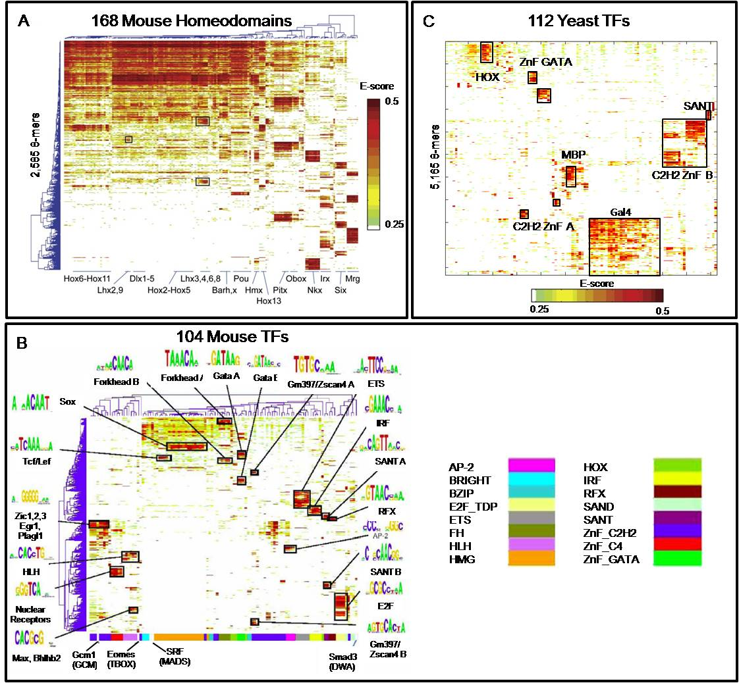
FIGURE 3.1 CLUSTERGRAMS SHOWING THE 8-MER PREFERENCES FOR THE TFS STUDIED BY (A) BERGER ET AL. (2006), (B) BADIS ET AL. (2009) AND BADIS ET AL. (2008). GENERALLY, TFS BELONGING TO THE SAME STRUCTURAL CLASS HAD MORE SIMILAR 8-MER PREFERENCES RELATIVE TO MEMBERS OF ANOTHER CLASS.

suggest that homeodomain sequence preferences may be best described as a composite of binding activities, rather than by a single dominant motif. Hence, conventional single motif representations such as consensus sequences and PWMs may be inadequate descriptors of the rich binding activities of homeodomains and perhaps TFs in general.

Exploring new motif representations
The ability of PBM assays to provide a readout of the relative affinities of TFs to every possible k-mer sequence necessitated the development of new data representations, such as E-score and Z-score profiles for all possible 8-mer sequences and provides an opportunity to evaluate these new data types against conventional PWMs. Using the homeodomains data as a test case, I performed simple precision-recall (PR) tests to evaluate the ability of PWMs in predicting the outcome of a replicate experiment in order to gauge the contribution of the dominant motif in determining the overall binding profile of each TF, relative to the E-score and Z-score representations. Representative PWMs were derived for each TF using Seed-and-Wobble (Berger et al. 2006) such that each motif captures the binding sites preferred by each TF. I then converted the PWMs into motif scores were calculated for all 8-mers using the Gomer scoring method (Granek and Clarke 2005), which estimates of the probability of transcription factor binding to each sequence.

The following graphs show the precision at 70% recall for four example homeodomains (Figure 3.2). Positives were defined by a moving threshold on E-scores (or Z-scores, if Z-scores were used as training/test) for the second independent array. At each threshold (i.e. each point on the graph) the precision statistic (True Positives / (True Positives + False Positives)) was determined for the value at which the recall statistic (True Positives / (True Positives + False Negatives)) is 70%. E-score (red), Z-score (blue), and SW (Seed-and-Wobble (Berger et al. 2006)) motifs (black and green) were defined on the original array. In virtually all cases, individual 8-mer E- and Z-scores reproducibly achieve higher precision at 70% recall than single PWMs alone, underscoring both the presence of TF sequence preferences that cannot be fully recapitulated by a single motif and the importance of retaining individual 8-mer profile scores.
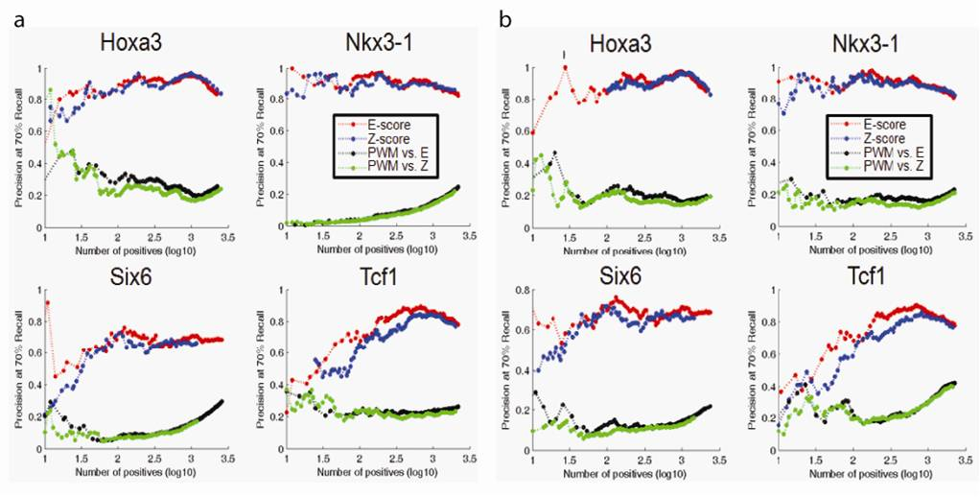
Figure 3.2 Precision at 70% recall plots. a) Results from training on the version of the array used for all homeodomains, and testing on an alternative array design. b) Results from training on the alternative array design, and testing on the version used for all homeodomains.

3.2.2 Many TFs exhibit multiple modes of binding that cannot be represented by a single pwm
Secondary motifs are prevalent amongst the studied TFs
Initial analysis of homeodomain proteins by PBMs suggested that the dominant motif of a TF often cannot explain its binding activities as well as a fully-specified 8-mer profile and is an inferior predictor of the binding profile of the same or similar protein on an array of an independent design. The prevalence and generality of this observation was explored across 21 additional TF structural classes, totalling to 104 mouse TFs in the later study by Badis et al. (2009). In that study, my collaborators Dr. Michael Berger and Dr. Anthony Philippakis modified their Seed-and-Wobble algorithm such that it could be run iteratively to search for additional motifs, distinct from the primary motif, represented by k-mers of high signal intensity not well explained by the primary motif.

Overall, at least 40% of the 104 mouse TFs examined in the Badis et al. (2009) study had clear secondary binding preferences, falling into four main types, classified as “positional interdependence” (19 TFs), “variable spacer length” (1 TF), “multiple effects” (≥ 16 TFs) and “alternate recognition interfaces” (≥ 5 TFs). TFs falling under “positional interdependence” preferred sequences which covaried at particular positions, favouring specific bases and disfavouring others. One example was the estrogen related receptor alpha, which had a strong preference for binding either CAAGGTCA or AGGGGTCA, but not CAGGGTCA or CGGGGTCA. Jundm2, belonging to the BZIP family, preferred a motif consisting of a variable length spacer centering the palindromic 6-mer TGATCA, while at least 16 other TFs fell under a combination of positional independence and variable spacers at different positions in the motif, classified as “multiple effects”. The binding activity of the TFs in the last category, “alternate recognition interfaces” is consistent with a model in which recognition of the cognate DNA sites is mediated through alternate structural features or changes in conformation. Moreover, for some TFs, the secondary binding preferences were almost as high affinity as the primary sequence preferences (the nuclear receptor Hnf4a, for example) and many were of lower affinity (e.g. the forkhead domain containing Foxa2). Together, the pervasiveness of secondary binding activities amongst the proteins studied not only goes against the assumption of positional independence in the common PWM models but also prompts an examination of whether generalized single PWM representations (additive models) are good enough approximations to describe the comprehensive measurements of protein-DNA interactions afforded by technologies such as PBMs.

Secondary motifs are unlikely to be motif-finding artefacts
The presence of secondary TF motifs as a general phenomenon has to my knowledge, never been described before. Therefore, it was important to ensure detection of secondary (and tertiary or generally, “n-ary”) motifs were not an unintentional by-product of the motif-finding process. To this end, we sought to confirm that the identified secondary motifs were unlikely to be artefacts of the Seed-and-Wobble algorithm in two ways: 1) my colleague Andrew Gehrke verified the binding of secondary sequences for 6 TFs (Hnf4a, Nkx3.1, Myb, Mybl1, Foxj3, and Rfxdc2) by EMSAs and 2) I tested Seed-and-Wobble on simulated long motifs to ensure that it does not erroneously identify multiple motifs instead of single motifs longer than the 10 bases the PBM designs fully sample.

One possibility causing false secondary motifs to arise could be due to the motif-finding program erroneously splitting up long motifs. To investigate whether the secondary motifs discovered using Seed-and-Wobble may have been due to artefacts stemming from potentially longer motifs, my colleague Dr. Michael Berger performed Seed-and-Wobble analysis on two different sets of 50 simulated, 14-bp motifs that I compiled, to search for primary and secondary motifs within the dataset of simulated “long” (14-bp) motifs. Unpublished data from the Bulyk lab found that synthetically simulated motifs were not accurate simulations of true motifs as they are not “round” in terms of “Hamming ball” motif space so hence, I generated two sets of simulated motifs based on real motifs.

First, I combined the primary and secondary motifs from the 6 TFs (Hnf4a, Nkx3.1, Mybl1, Foxj3, Foxk1 and Rfxdc2) in the Badis et al. (2009) study for which the secondary motifs were verified by EMSA, trimming the flanking positions so that the resulting motifs were 14 bp long. Next, I took 24 long motifs from JASPAR (Sandelin et al. 2004) (widths 11 to 17) and either removed the flanking positions or added new columns to the end of the motif from columns derived from the middle of the motif to get a final width of 14. Some motifs had exactly 14 positions, in which case, nothing further was done to the columns. I then combined 40 pairs of shorter motifs from JASPAR (Sandelin et al. 2004) (widths 5 to 11) and either removed the flanking positions or added new columns to the end of the motif from columns derived from the middle of the motif to get a final width of 14. Some concatenated motif pairs totalled exactly 14 positions, in which case nothing more was done to the columns. The ordering of the motif pair concatenation was random. This set of motifs constituted as the first set of 50 simulated motifs, while the 2nd set of 50 simulated motifs corresponded to shuffled versions of the motifs in the first data set, where the positions, of the PWM were shuffled. Since PBM data from different de Bruijn sequences are highly reproducible, and since this test does not depend on the particular de Bruijn sequence used, I used the GOMER scoring scheme (Granek and Clarke 2005) to score each of these 100 simulated motifs against the probe sequences of array #1 (de Bruijn sequence #1, arbitrarily). For both sets of motifs, the data were then “noised” to simulate PBM data. Specifically, the simulated motifs were scored against all the 60-mer array probes using GOMER. The ln(GOMER) scores were then converted into z-scores and split into 100 bins. The standard deviation within each bin was calculated and Gaussian noise was added by generating new z-scores using the mean and standard deviation in the bin. The standard deviation was scaled with a multiplicative factor such that the scores on the low end were made noisier than the scores on the high end, in order to simulate the noise distribution in real PBM data. This procedure outputted a set of scores representing the binding probabilities of a simulated TF to each of the array probes as specified by its simulated motif. These outputted scores correspond to the simulated PBM data, with probes ranked according to their GOMER scores (probabilities) and analyzed for motif content using Seed-and-Wobble by Dr. Michael Berger.

Seed-and-Wobble was highly successful in identifying the long, 14-bp simulated motifs, such that in 97% of the 14-bp simulated motifs, the planted motif was successfully recovered as the primary motif with a top seed 8-mer E-score ≥ 0.45. Approximately 41% of the primary motifs technically had a “secondary motif” that could be identified by Seed-and-Wobble with a top seed 8-mer E-score ≥ 0.45. However, for the vast majority of those cases, given their low quality (low information content and/or similarity to the primary motif), they likely would not have been reported as significant secondary motifs as the primary and secondary motifs had important differences between them in the real data for the 104 mouse TFs.

Only in 10 cases could the secondary motif recovered be misinterpreted as an example of position interdependence, but given our strict criteria for recognizing secondary motifs, at least 8 of these would not have been given that distinction, in large part due to their long lengths. Overall, this simulation exercise suggests that essentially all of the secondary motifs found in the Badis et al. study (Badis et al. 2009) are unlikely to be artefacts of the motif-finding procedure due to long motifs.

A regression-based multiple motif model
Given the prevalence of secondary motifs and richness and volume of PBM data now available in the Badis et al. (Badis et al. 2009) dataset, I wanted to explore the relative merits of a multiple-motif model as an improved representation of protein-DNA binding specificities, particularly amongst proteins exhibiting secondary sequence preferences. Hence, to evaluate the general applicability of a multiple-motif model, I applied a linear regression approach called Lasso (Tibshirani 1996) to learn weighted combinations of position weight matrices (PWMs) generated from several different motif-finding algorithms and to see what fraction of proteins and their DNA binding specificities might be best represented by multiple motifs. Lasso regression was used here as opposed to other regression methods as it is useful in feature selection; it imposes a constraint
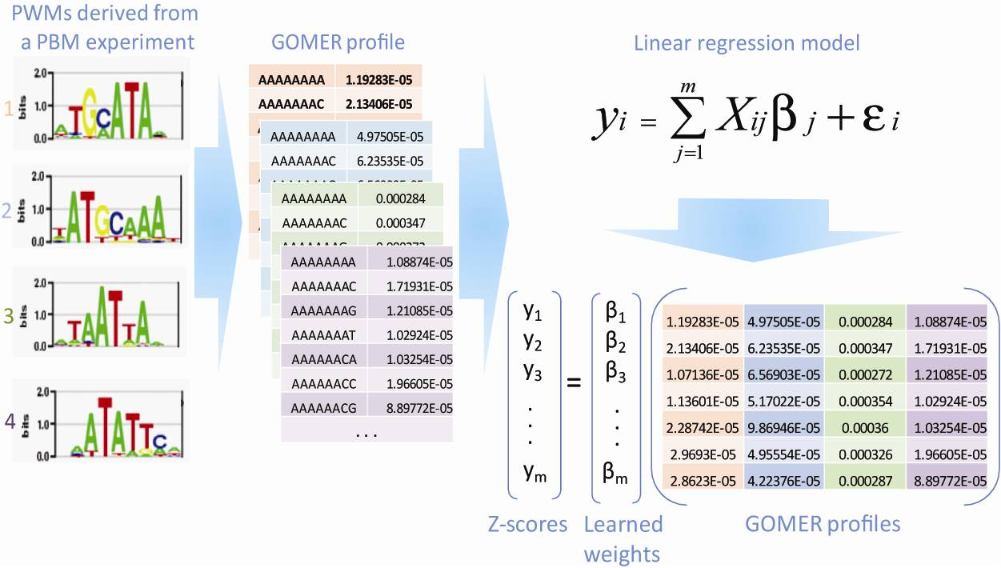
FIGURE 3.3 SCHEMATIC SHOWING THE REGRESSION-PROCEDURE USED TO SELECT THE MOST INFORMATIVE MOTIF(S).

on the sum of the regression weights, weighting only the important features (8-mer score conversions of the PWMs from the training array) and forcing the rest to have zero weights (Figure 3.3).

I then tested the predictive power of primary to n-ary PWMs trained by several motif finders: Seed-and-Wobble (Berger et al. 2008) (untrimmed and trimmed motifs as described by (Badis et al. 2009)), RankMotif++ (Chen et al. 2007), and Kafal (described in Section 3.4.4) as well as the Lasso multiple motif model and fully specified 8-mer models (8-mer scores) on one array (array design #1), by evaluating their ability to predict the 8-mer scores on a replicate array (array design #2) and vice versa using precision-recall (PR) statistics, area under receiver operator characteristic curve (AUC) statistics and measurement of percent variance explained (see Section 3.4.3 for method details). In both PR and AUC analyses, 8-mer E-scores from one array replicate were evaluated against the E-scores of the other array replicate. For the regression-derived combination of PWM motif models, an additional statistic representing the change in percent variance explained when each selected PWM was removed from the model was calculated to evaluate the relative “importance” of each selected motif to the overall multi-PWM model.

Figure 3.4 shows the result of this analysis for one example protein, Hnf4a where Figure 3.4a was generated using Array 1 as the training set and Array 2 as the test data and vice versa in Figure 3.4b. The AUC (Area under the ROC curve) metric on the y-axis is a measure of how well each motif representation trained on one array is able to predict the binding data measured on the other array over a range of positives defined by moving score thresholds. Log10(1-AUC) is shown to highly the differences between the methods, all of which have an AUC near 1 (where 1 is perfect predictive power). The solid black line (“Full Lasso model”) shows the performance of the regression-based multiple motif model while all other lines indicate the performance of single motifs identified by the three other motif-finding algorithms: Seed-and-Wobble, RankMotif++ and Kafal. For clarity, Figure 3.4 only shows individual motifs selected by Lasso as part of the multiple-motif model while the performance of the non-selected motifs is not shown (refer to the supplementary document accompanying (Badis et al. 2009) for the full figure). The solid black line of the Lasso multiple-motif model is clearly higher than all other lines in the figure, over the entire range of positives defined at different 8-mer score thresholds, indicating that for Hnf4a, a multiple-motif model best describes its PBM binding profile over any single PWM derived from the same data.

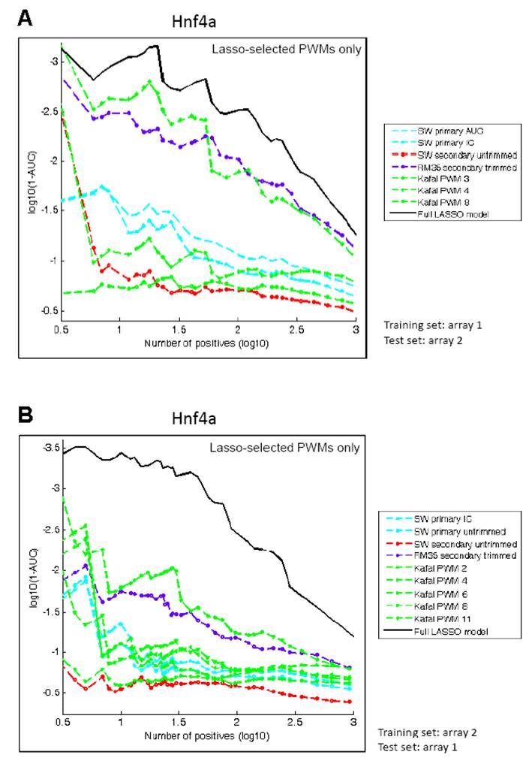
FIGURE 3.4 GRAPHS SHOWING LOG10(1-AUC) (AREA UNDER ROC CURVE) (Y-AXIS) VERSUS LOG10(NUMBER OF POSITIVES) (X-AXIS) FOR HNF4A, DESCRIBING THE PERFORMANCE OF EACH MOTIF MODEL LEARNED FROM ONE PBM REPLICATE IN PREDICTING THE BINDING PROFILE OF ANOTHER PBM REPLICATE.

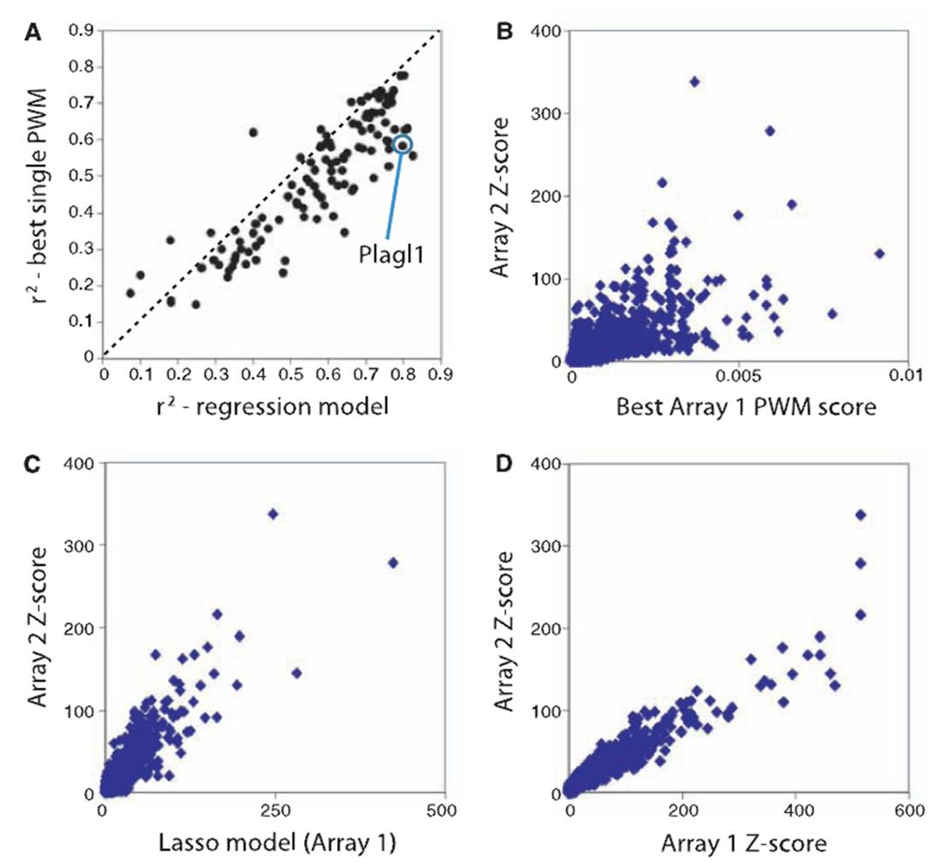
FIGURE 3.5 SCATTERPLOTS SHOWING THE ABILITY OF DIFFERENT MOTIF REPRESENTATIONS LEARNED FROM ONE PBM EXPERIMENT IS ABLE TO PREDICT THE 8-MER BINDING PROFILE OF A REPLICATE EXPERIMENT FOR THE TF PLAGL1 (B-D, WHERE PWM SCORE IN (B) REFERS TO THE GOMER SCORE AND THE LASSO MODEL SCORE IN (C) IS THE PREDICTED Z-SCORE). (A) SCATTERPLOT OF PERCENT VARIANCE EXPLAINED (R²) BY THE SINGLE BEST MOTIF VERSUS THE LASSO MODEL FOR ALL 104 TFS IN (BADIS ET AL, 2009).

Overall, this analysis showed that for all but 15 proteins, a multiple-motif representation was better suited to describe their binding preferences than a single motif (Figure 3.5a). Using a percent variance explained measure (r²), I asked for each of the 104 TFs in the Badis et al. study
(Badis et al. 2009), how well each of their single best motifs (defined as the one with the highest r² value) learned from one PBM array predicts the 8-mer binding profile of a replicate PBM. I then used the same measure and asked the same thing of the Lasso multiple-motif model and compared their performance against each other in a scatterplot. As shown in Figure 3.5a, most of the points (each representing a set of replicate PBM experiments for each TF), lie below the dotted line, indicating that in a head-to-head comparison, for all but 15 TFs, a multiple-motif model clearly captures the richness of the TF sequence preferences better than a single PWM model. Many of the 15 points not below the dotted line lie right on it, meaning for those TFs, a single motif model and a multiple-motif model perform nearly identically. Moreover, the majority of the points below the dotted line have high r² values, indicating that not only the multiple-motif model outperforms the single PWM model for those TFs, but that the variance in the binding profile is also well captured by the model. However, I note that not all of the motifs in the multiple-motif model represented distinct binding preferences as those designated as n-ary motifs, but nevertheless, they captured different subsets of the k-mer data.

Looking more closely at the level of the 8-mer binding profile for an example TF, Plagl1, it is clear that data between two PBM replicates correlates very well and is highly reproducible (Figure 3.5d). When compared to the 8-mer GOMER scores for the single best motif, the scatter is much wider, indicating that the binding preferences for the 8-mers at the extremes of the scatter are not well captured by the single best PWM (Figure 3.5b). In contrast, the multiple-motif model captures the binding profile much better and nearly as well as an experimental replicate (Figure 3.5c).

One possible cause for concern given our use of motif-finding programs of our own design rather than a suite of commonly-used programs is the possibility that the single best motif performs more poorly than the multiple-motif model simply because the programs perform poorly themselves. Although the dominant motif for most TFs tested is capable of reproducing the 8-mer ranks of a replicate array nearly as well as a replicate experiment or a multiple-motif model, they do in general account for a good proportion of variance explained, such that almost all motifs selected by Lasso explain 10% or greater the variation in replicate 8-mer data. If no relationship between the motif and the 8-mer data then the correlation and percent variance explain would be near 0.

Putting the performance of the motif-finding programs head-to-head and comparing the percent variance explained by the best motif from each of Seed-and-Wobble, RankMotif++ and Kafal over the entire set of 104 mouse TFs, I found RankMotif++ to be the most consistent. RankMotif++ PWMs generally yielded better performance measures over the full range of sequence preference scores from high to low affinity as compared to Seed-and-Wobble or Kafal PWMs. Comparing the motifs from the three programs using TomTom (Gupta et al. 2007), using an E-value threshold to define similarity, I found that surprisingly, motifs that are clearly related can yield very different performance measures. 37% of the pairwise PWM similarity comparisons considered by TomTom to be the for the same TF by the three methods have differences in ≥ 10% in variance explained on the 8-mer ranks of the replicate array, suggesting that small differences between motif models can have an effect on their explanatory power. When comparing distinct motifs (defined by TomTom E-value > 0.01), 42% of the pairwise PWM similarity comparisons differed no more than 10% in variance explained on the 8-mer ranks of a replicate array. Kafal most often yielded diverse PWMs that captured the sequence preferences well as 35% of Kafal PWMs were selected by Lasso, while 30% and 19% of the PWMs for RankMotif++ and Seed-and-Wobble were positively weighted respectively.

Multiple-motif models unlikely to stem from noise in PBM data
One common concern with regression models is that of overfitting. To determine whether the Lasso regression model selects multiple PWMs to fit noise rather than signal in the PBM data, I ran a series of simulations to gauge the robustness of the model to noise. The goal of this exercise was to see if the regression procedure would select multiple motifs starting with noisy data derived from a single motif. To do this, I generated ten sets of simulated PBM data from each of ten motifs selected from JASPAR (Sandelin et al. 2004) (Figure 3.6), scored them with GOMER (Granek and Clarke 2005) and used the resultant scores as proxies for binding measurements. The GOMER (Granek and Clarke 2005) scores were converted into Z-scores and split into 100 bins across the score range and the mean and standard deviation was calculated within each bin. In order to simulate the noise distribution of real PBM data, Gaussian noise was added by scaling the standard deviation with a multiplicative factor such that scores on the low end were made noisier than scores on the high end. These “noised” scores were treated as simulated PBM data and used as input into Kafal to exhaustively identify motifs within the data. This was repeated for each of the 100 simulated data sets and the resultant motifs were given to Lasso to select the motif or motif combinations that best fit the simulated Z-scores. Although circular in logic, training and testing on the same set of simulated Z-score, the purpose of this exercise was just to see whether multiple motifs could be artificially selected by the regression process from data simulated from single motifs so I was not concerned with the specific predicted values.
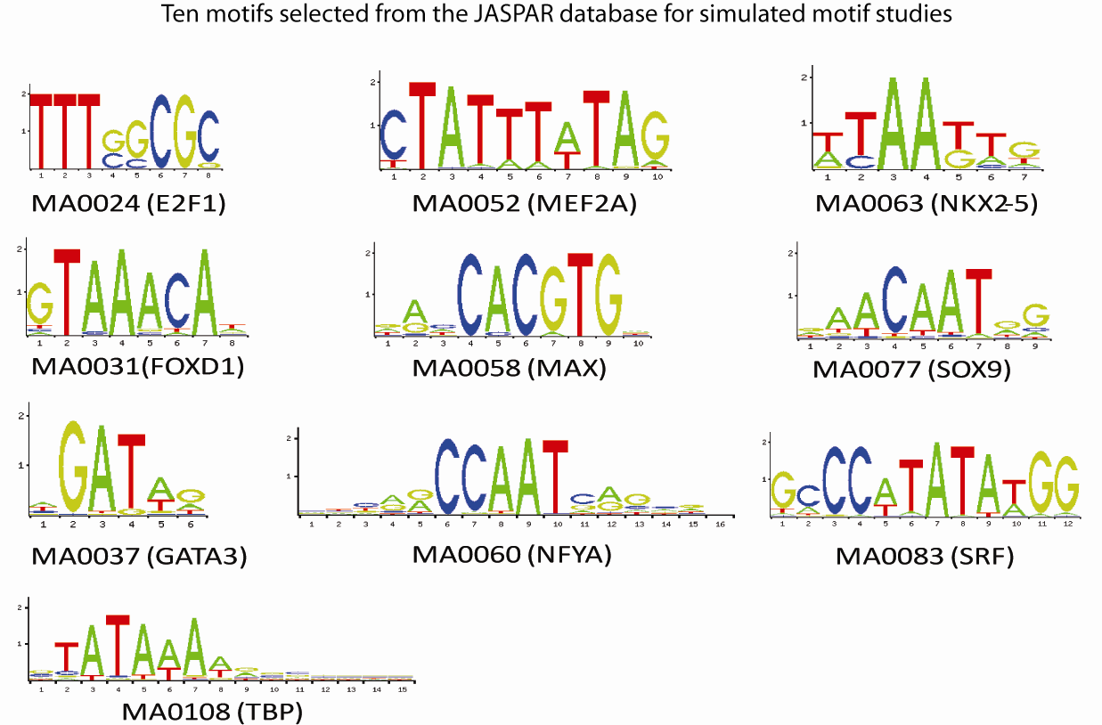
FIGURE 3.6 TEN MOTIFS FROM THE JASPAR DATABASE (SANDELIN ET AL, 2004) SELECTED FOR ROBUSTNESS-TO-NOISE SIMULATIONS
Out of the 100 simulated datasets, Kafal identified more than one motif in 24 and Lasso selected more than one motif in 4 out of 100 datasets (false positive rate = 16.6%). One of the multiply-weighted datasets came from data derived from GATA3 (MA0037) and the other from data derived from NFYA (MA0060). Two motifs were given non-zero weights by Lasso in the GATA3 dataset and upon manual inspection of the motifs, one was highly similar to the original input GATA3 motif while the other appeared to be the same motif but repeated in tandem. Both motifs accounted for approximately the same variance (~13%) and both were chosen by the regression model. Similarly, the multiple motifs selected by the regression model in the three NFYA datasets were similar by visual inspection and accounted for roughly the same proportion of variance explained. However, given the similarity between the selected motifs in the simulated data, they would have been unlikely to be counted as bona fide secondary motifs as the primary to n-ary motifs in the real data generally had distinct differences. The results were also similar when I extended this analysis to test for tolerance to additional noise by increasing the spread in the noise profile of the simulated datasets by increasing the multiplicative factor (data not shown).
In addition, I performed a complementary test in which I created tandem motifs by pairing the same six out of the ten JASPAR (Sandelin et al. 2004) motifs and asking how frequently out of thirty simulated data sets (3 motif pairs x 10 independently “noised” simulated data sets) the constituent motifs were selected by Lasso in a multiple-motif model. In ten out of the 30 simulated datasets, Kafal returned multiple PWMs and from that, Lasso selected multiple PWMs in five (50% success rate). Despite the misleading success rate, both the FOXD1-MAX and GATA3-SOX9 combinations were readily picked up by the regression model and only the E2F1-TBP tandem motif was missed. This was likely because the tandem motif was 23 bp wide and the simulated data was derived from GOMER (Granek and Clarke 2005) scoring of 8-mers and it is possible that if the PBM binding measurements were simulated by GOMER (Granek and Clarke 2005) scoring against the full 35-mer instead, the success rate would be much higher. It should also be noted that most motifs derived from proteins in the structural classes under examination tend to be under 10 bp in length based on experimental evidence independent from PBMs and a 23bp long motif would be highly unusual in real data.

3.2.3 MORE: Towards a motif model evaluation framework
Motivated by the power and generality of multiple-motif models evident from the above analysis, I in conjunction with Dr. Lourdes Peña-Castillo extended this work by developing a generalized framework for identifying a set of binding specificities that best explain the DNA-binding preferences of a given transcription factor.

Consider the average biologist who has performed a series of ChIP-chip, ChIP-seq, CSI or PBM assays for several DNA-binding proteins and is now interested in deriving a motif-model that describes the measured binding events and reflects the relative binding affinity of the proteins to the motif-model. He or she retrieves a set of sequences (such as sequence reads or array probes) and a measure of the relative affinity of each protein for them (such as read count or probe intensity) and decides to run the sequences through a published motif-finding algorithm and is faced with questions such as which motif-finder(s) to use and how to select the most representative motif(s)?

In the following section, I describe a novel regression‐based evaluation method named MORE (Multiple‐motif Regression‐based evaluator) as a principled way for the average biologist to select the motif(s) that best reflect their experimental measurements. It is not often readily clear to the average user, how to interpret multiple motifs returned from different motif-finding programs, each with different scoring systems, p-values, underlying methods, assumptions about the underlying data. The MORE framework is designed to evaluate motif-models derived by different motif-finding algorithms, obtain a non-redundant set of motifs and select the (set of) motif(s) that best explain the measured binding data, taking the guesswork out of the process for the user. MORE can take advantage of the full affinity spectrum of measurements afforded by PBMs, CSI and genome-wide ChIP assays for example, and can evaluate all motifs outputted by any set of motif-finders, regardless of stringency of settings and input sequences used to run them. Additionally, modularity in MORE’s framework allows the user to use motif-finders such as MatrixREDUCE (Foat et al. 2006) and PREGO (Tanay 2006) that use a regression approach to fit motif-models over the entire affinity range of the measured data set without the need to rigidly threshold “bound” from “unbound” sequences. Hence, is designed to MORE relieve the typical bench biologist from the mundane task of selecting a motif-finding algorithm and appropriate parameters to use through trial and error.

MORE’s general motif evaluation framework is described in Figure 3.7. A typical procedure to identify motif models from experimental data would end after execution of motif-finding algorithms (Figure 3.7-III). MORE extends this process by reducing redundant motif models using TomTom (Gupta et al. 2007) (Figure 3.7-IV) and applying linear regression (Figure 3.7-VII), followed by a cross-validation evaluation procedure (Figure 3.7-VIII) to select motif models and combination of motif models that best explain the replicate experimental binding data. The linear regression step provides not only a method to evaluate how well each motif model captures the underlying binding data, but also a method to incorporate multiple PWMs into a single model to represent the binding activities of TFs.

MORE pilot project: 7 yeast TFs from Badis et al. (2008)
As a pilot project, I tested MORE on a small set of published PBM data (Badis et al. 2008) to demonstrate its utility in evaluating motifs derived from four well-known motif-finding algorithms (AlignACE (Hughes et al. 2000), MEME (Bailey and Noble 2003), BioProspector (Liu et al. 2001) and MotifSampler (Thijs et al. 2001)) and Kafal (Section 3.4.4). Note that Seed-and-Wobble and RankMotif++ were not used here as they are not widely-used methods and either imposes a steep learning curve to use or is intimately and exclusively tied to the analysis of PBM data. Starting with replicate PBM data for seven yeast TFs (Aft2, Dot6, Gln3, Mbp1, Pho2, Pho4, and Skn7) (Badis et al. 2008) processed in the typical manner as described in Figure 3.7, a subset of highly-bound 8-mers for each experiment was determined by applying a Z-score threshold. This threshold was obtained by plotting the Z-scores in ascending order and identifying the score at which the slope becomes less than 0.01, near the inflection point at which the Z-score plateaus. Hence, this threshold is variable
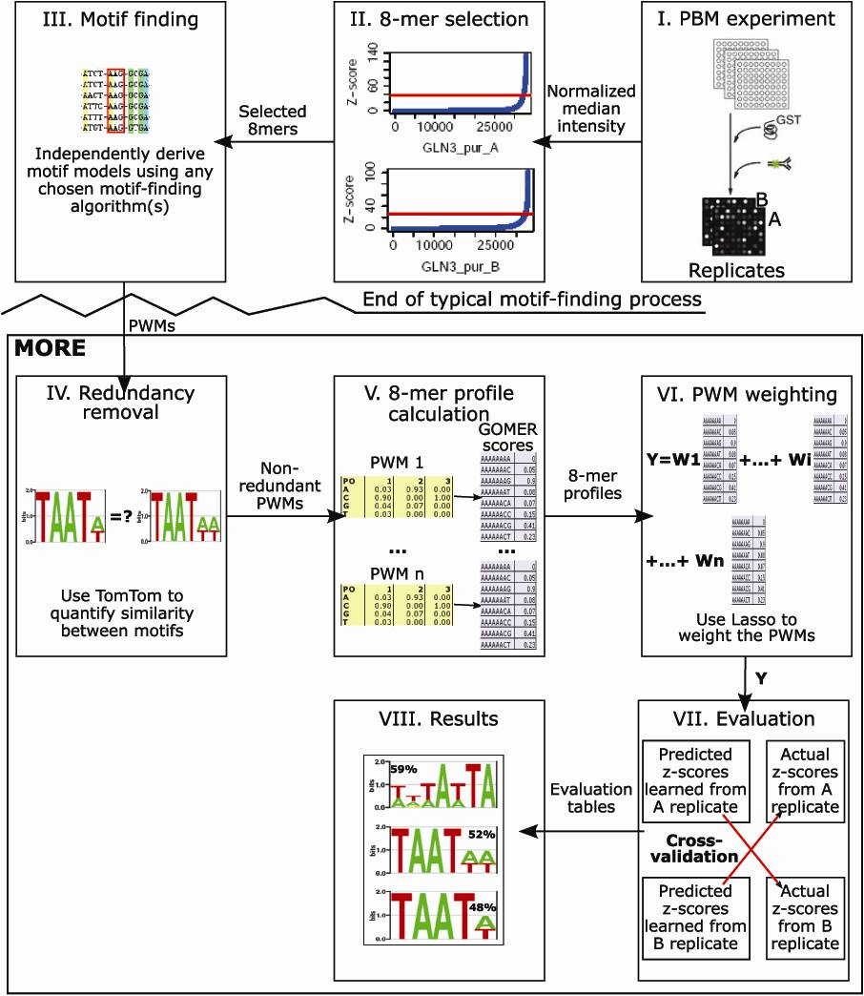
FIGURE 3.7 FLOWCHART SHOWING THE MOTIF EVALUATION PROCESS DEFINED BY THE MORE FRAMEWORK
and is adjusted based on the distribution of scores for each experiment. Figure 3.8 shows 8-mers preferably bound by each of the TFs in the dataset as a clustergram. Not only do the TFs appear to occupy unique portions of the 8-mer sequence space, the 8-mer preferences between replicates were highly reproducible. These subsets of 8-mers identified were then used as input to five different motif-finding programs.
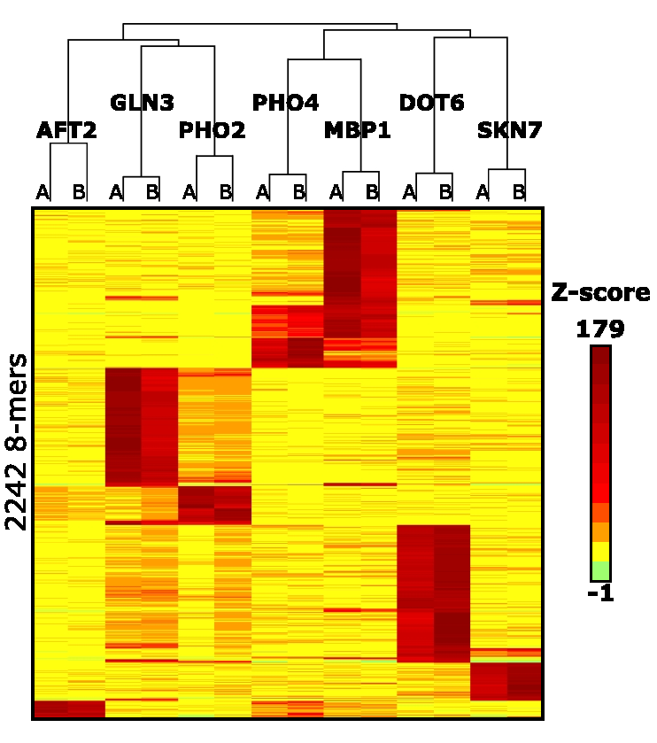
FIGURE 3.8 A CLUSTERGRAM REPRESENTATION OF THE SETS OF 8-MERS PREFERRED BY EACH TF ACROSS REPLICATE PBM EXPERIMENTS
Redundancy and agreement in motif models
One of the parallel objectives in the development of MORE was to assess the performance of different motif-finding programs en route to determining the effectiveness of MORE in reducing motif redundancy. To do this, I initially selected four popular motif-finding programs (AlignACE (Hughes et al. 2000), BioProspector (Liu et al. 2001), MEME (Bailey and Elkan 1994) and MotifSampler (Thijs et al. 2001)) and one newly developed program in conjunction with Dr. Lourdes Peña-Castillo, Kafal to evaluate. Three of the five motif-finders, AlignACE, Bioprospector and MotifSampler, had to be run once for each tested width from 5 to 14, resulting in a large number of returned motifs. To determine the level of PWM redundancy from each motif-finder, TomTom (Gupta et al. 2007) (Figure 3.7-IV) was used to determine the similarity of each motif to all other motifs returned by each motif-finder. Figure 3.9a shows the average number of motif models returned by each method (grey) over all 14 experiments, the number of non-redundant motifs as determined by the TomTom analysis (green) and the number of motifs eventually selected by the evaluation step of MORE. Figure 3.9b shows the same breakdown except averaged over all motif-
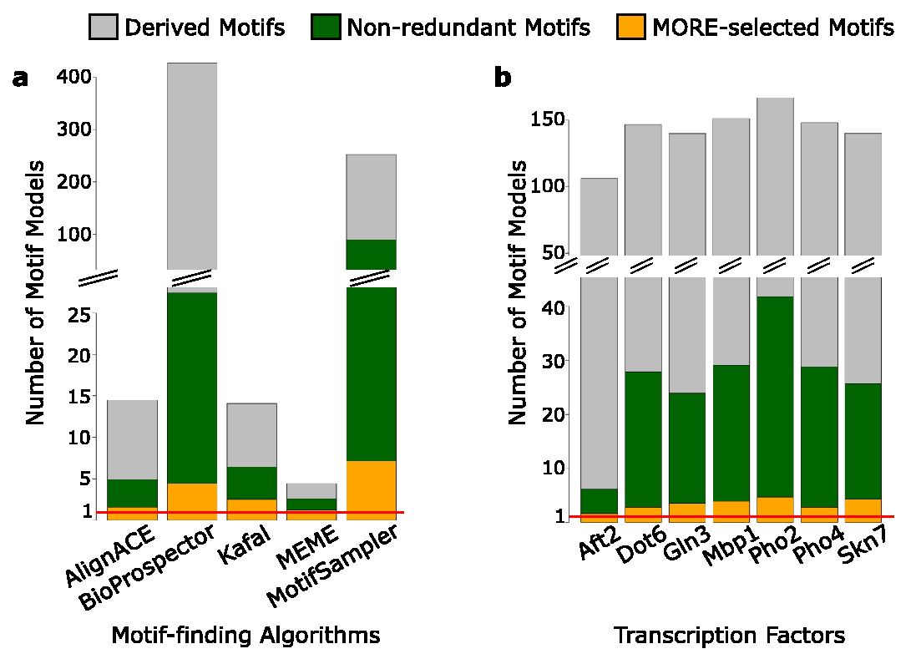
FIGURE 3.9 (A) THE AVERAGE NUMBER OF MOTIF-MODELS DERIVED BY EACH METHOD, BROKEN DOWN BY TOTAL NUMBER OF MOTIF-FINDER-DERIVED MOTIFS, NON-REDUNDANT MOTIFS AND MOTIF-MODELS SELECTED BY MORE. (B) SAME AS (A) BUT BROKEN DOWN BY EACH PAIR OF PBM EXPERIMENTS FOR EACH TF.

finders for both replicates for each TF. In each case, the reduction of motifs is very dramatic after step IV of MORE, particularly for BioProspector, which puzzlingly returns exactly the number of motifs requested (40 for each motif width). TomTom (Gupta et al. 2007) was also used to determine whether the motif(s) derived from one motif-finder matched those derived from another, such that an “agreement” set was constructed from motifs deemed similar by TomTom analysis (TomTom E-value < 0.01) and supported by the majority (at least 3 of the 5) of the motif-finders used. The agreement set for all TF motifs is shown in Figure 3.10, alongside the predicted motifs derived from ChIP-chip data and computational analyses (MacIsaac et al. 2006). Note that the agreement set contains some redundant motifs as TomTom was not run within the agreement set in order to be as inclusive as possible.
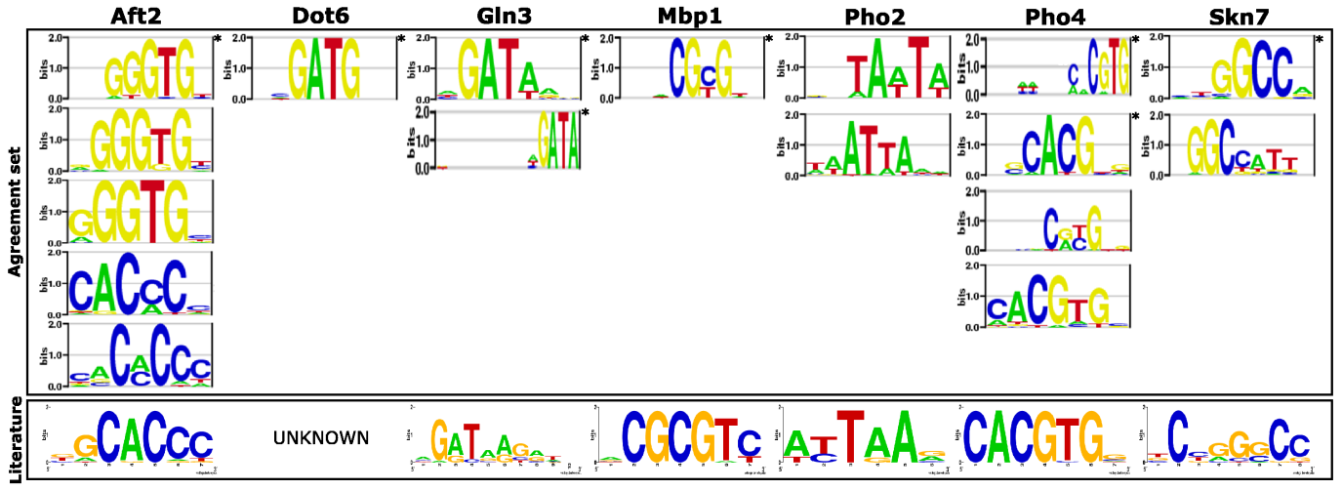
FIGURE 3.10 COMPARISON OF THE PWMS IN THE AGREEMENT SET (CONSISTING OF PWMS DERIVED FROM EACH OF THE FIVE MOTIF-FINDERS THAT MATCH AT LEAST TWO OTHER MOTIF-FINDING METHODS) TO THE KNOWN PWMS IN THE LITERATURE (MACISAAC ET AL, 2006).

MORE selects the important and informative motif models
Next, to determine which PWM(s) in the non-redundant set of motif models obtained by the five motif-finders best captured the 8-mer binding specificity profiles, I applied steps VI to VIII (Figure 3.7) of the MORE method. To do this, I used a cross-validation procedure to ask how much of the variance in the measured intensity data of one array replicate can be accounted for by the PWMs obtained from the intensity of the other replicate. This procedure was applied to the motif sets derived from each motif-finder as well as the agreement set in order to compare their respective performances. The key statistic used here is percent variance explained, which is reported for each motif model (PWM or linear regression model) trained on one replicate and is a measure of how much of the variation in the data of the opposing replicate each one accounts for. In the linear regression models involving multiple PWMs, the relative weighting or importance of each PWM is also assessed by looking at the change in the variance explained by the model when each PWM is removed in turn. Figures 3.11 and 3.12 show that in general, multiple non-redundant motifs explain equally or better the variance in the measured intensity data than any single PWM and this is consistent across all the motif-finders tested. Moreover, MORE was not only able to
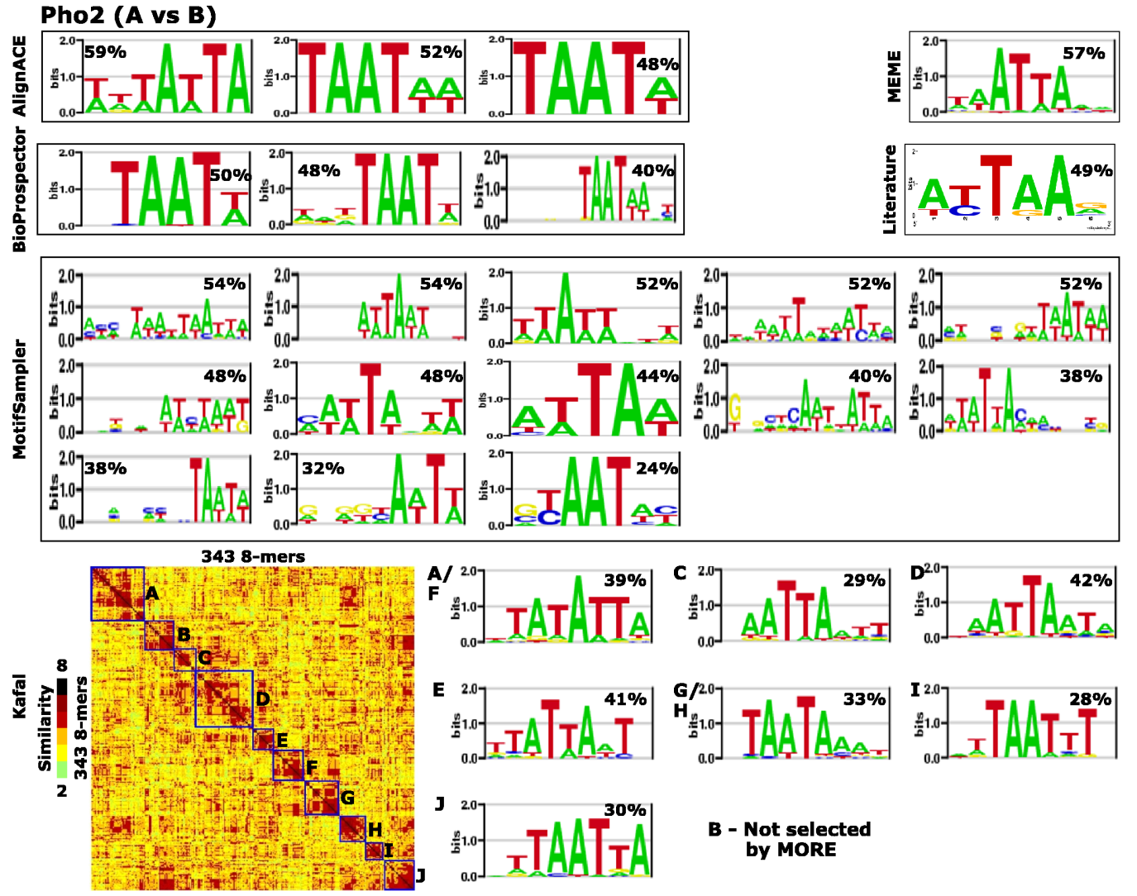
FIGURE 3.11 A DETAILED EXAMPLE SHOWING HOW MULTIPLE, DISTINCT MOTIF MODELS CONTRIBUTE TO EXPLAINING THE EXPERIMENTAL BINDING DATA. THE A ARRAY 8-MER Z-SCORE PROFILES FOR TF PHO2 WAS USED TO DERIVE MOTIF=MODELS USING EACH OF THE 5 PROGRAMS AND TESTED ON THE B ARRAY REPLICATE 8-MER Z-SCORE PROFILES. THE PERCENTAGE OF VARIANCE EXPLAINED (R²) BY EACH MOTIF MODEL ON THE B REPLICATE 8-MER Z-SCORE PROFILES IS DEPICTED ALONGSIDE EACH MOTIF MODEL. KAFAL ADDITIONALLY OUTPUTS A MATRIX OF HIGHLY-BOUND 8-MER EDIT DISTANCES, WHERE THE LETTERED BOXES INDICATE SUBSETS OF 8-MER SEQUENCES WITH SIMILAR RELATIVE BINDING AFFINITIES, FROM WHICH CORRESPONDINGLY LETTERED PWMS ARE DERIVED

further reduce the number of motif models derived by each method; it did so by selecting only those that was most informative (Figure 3.12).

For instance, Pho2 is known to be involved in several different pathways, including purine nucleotide biosynthesis, histidine biosynthesis and phosphate utilization (Daignan-Fornier and Fink 1992). It contains a homeodomain and preferably binds the canonical TAAT homeodomain core motif. However, Pho2 appears to exhibit multiple binding activities where the TAAT-flanking nucleotides are variable (Figure 3.11). Interestingly, this set of Kafal-derived motifs selected by MORE represent the best combination of PWMs that explain the measured binding data (78%). One tempting hypothesis is that the multiple unique binding preferences of Pho2 allows it to precisely regulate genes in these pathways and further experimental evidence would be required to confirm this hypothesis, but this analysis forms a basis for such future experiments.

MORE can differentiate between motif models derived for distinct transcription factors
I next examined the stability and robustness of MORE, particularly its consistency in the selection of PWMs each run, the relative magnitudes of the weights it determines as well as the false positive rate. Using a bootstrapping test with 1000 pseudo-replicates for each combination of PBM array replicate data and motif-finder, I found the magnitudes of the PWM weights to be quite stable. 75% and 81% of the time, the PWM weights assigned by MORE were within the 95% and 99% bootstrap confidence intervals respectively. To estimate MORE’s false-positive rate and sensitivity to noise and error in the motifs, I ran MORE using the union set of motif models from all seven yeast TFs in the pilot data set to ask it to choose the PWM or combination of PWMs that best explain the binding data of each TF individually. A total of 333 PWMs derived by the five motif-finders were considered in this test and only 25 (7.5%) were incorrectly chosen by the regression step (i.e.,
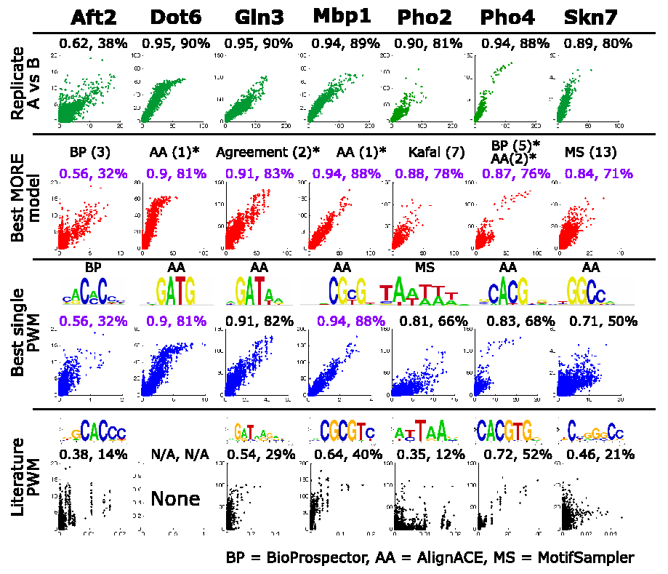
FIGURE 3.12 SCATTERPLOTS SHOWING THE REPLICATE ARRAY DATA AND PREDICTED Z-SCORES TRAINED ON PWMS (BEST SINGLE, COMBINATION AND LITERATURE) FROM ONE ARRAY REPLICATE VERSUS THE MEASURED Z-SCORES OF THE OTHER ARRAY REPLICATE. THE BEST PERFORMING EXAMPLE (EITHER ARRAY A VERSUS B OR VICE VERSA) WAS CHOSEN FOR EACH TF. PEARSON R AND THE PERCENTAGE OF VARIANCE EXPLAINED IS DISPLAYED NUMERICALLY ABOVE EACH GRAPH, WITH THE BEST FOR EACH TF (COLUMN) IN PURPLE. THE CORRESPONDING SEQUENCE LOGOS FOR THE BEST SINGLE AND LITERATURE PWMS ARE SHOWN ABOVE EACH SCATTERPLOT. ASTERISKS INDICATE CASES IN WHICH THE AGREEMENT SET IS TIED WITH THE BEST PERFORMING COMBINATION. ENCLOSED IN PARENTHESES IS THE NUMBER OF PWMS IN THE MORE-SELECTED MODEL.

chosen for the wrong TF). 12 (or 48%) of those 25 false positives were selected to explain Mbp1 binding data but were actually learned from the Pho4 data. However, as Figure 3.8 shows, the Z-score profile of Pho4 is subsumed by the Mbp1 profile, indicating a partial overlap in their sequence binding preferences. The known consensus sequences for Pho4 (CACGTGS) and Mbp1 (ACGCGT) confirms this. Hence, MORE is a robust to noise and extra motifs in the input set.

Comparison of performance between motif-finders and MORE
Figure 3.12 shows the Pearson correlation and the percentage of variance explained by the fully-specified 8-mer Z-score profile of one array replicate (used here as the gold standard), the selected MORE motif models, the best single PWM derived by any method and the motif from (MacIsaac et al. 2006) to the full 8-mer Z-score profile from the other array replicate (either replicate 1 vs. replicate 2 or vice versa). According to these evaluation criteria, MORE-selected PWM(s) was/were equal to or, in several cases, better than any single best PWM derived by any motif-finder or taken from the literature. These results suggest that a PWM or a combination of PWMs MORE chose was able to predict the 8-mer binding specificity profiles of the of the other array replicate with the highest degree of correlation.

To compare and rank the different motif-finding methods, each of them were evaluated by three criteria: motif-redundancy, predictive power of single PWMs and predictive power of PWM combinations as determined by MORE. Rankings by criteria and method are listed in each cell and descriptive statistics in brackets. The percentage of non-redundant motifs is based on the ratio of non-redundant motifs found by TomTom (Gupta et al. 2007) and the total number of motif models returned by each motif-finder. The mean, variance explained and standard error of the mean over all replicate 1 vs. replicate 2 and replicate 2 vs. replicate 1 tests are reported for single PWMs and multi-PWM combination models. The most highly-ranked motif-finding method is presented in bold for each criterion. Table 3.1 shows the ranking of the motif-finders relative to each other based on these three evaluation criteria. According to this evaluation result, if one had to choose a single representative PWM for further analysis, AlignACE and MEME would be the motif-finders for this task. The motifs in the agreement set were second best in terms of predictive power of single PWMs and MORE-determined PWM combinations. This indicates that indeed, motifs in the agreement set are more likely to represent the actual binding activities of the TFs.
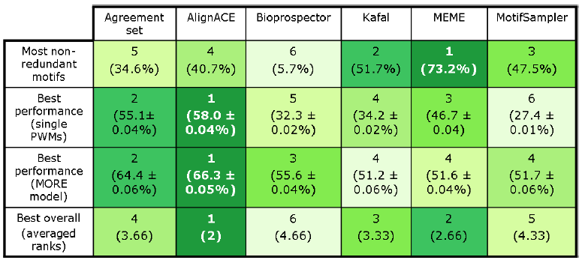
TABLE 3.1 SUMMARY STATISTICS AND OVERALL RANKINGS ACROSS THE DIFFERENT MOTIF-FINDING METHODS. RANKINGS BY CRITERIA AND METHOD ARE LISTED IN EACH CELL AND DESCRIPTIVE STATISTICS IN BRACKETS.

In general, the methods which gave fewer motifs (AlignACE and MEME) often returned the most dominate motif (highest affinity mode of binding), accounting for much of the variance in the measured 8-mer intensities (see Figure 3.9a and Table 3.1). In contrast, methods that gave more motifs (Kafal and BioProspector) tended to return a dominant motif along with several lower affinity motfs that account for a smaller fraction of the explained 8-mer intensity variance, but these lower-affinity motifs together with the dominant one explain the binding data as well and often better than the dominant one.

By MORE’s evaluation criteria, the motif models and motif model combinations selected for each of the seven TFs in this study recapitulated the observed binding data at least as well and often better than the best single PWM representation. When comparing to the gold standard of the fully-specified 8-mer Z-score profile of the array replicate, the MORE motif models performed nearly as well. I interpret this result as evidence that the PWM model often does not provide the best possible description of DNA-binding activities and that the description can be improved by a linear model of a small number of motifs.

Improvements to MORE and application to Berger et al. (2006) data
Following the pilot study, I made several modifications to the MORE pipeline. Although a number of motif-finders could be used in step III (Figure 3.7), several commonly-used ones were selected for evaluation in the course of the development of MORE. One of those was MotifSampler, which has now been excluded from step III. It yielded not only the greatest number of redundant motifs in the TomTom analysis after BioProspector and the worst performing single PWMs (Table 3.1), but also the lowest percentage of derived motifs that agreed with the other motif-finders in the “agreement set” (0.69% for MotifSampler, in contrast to 34% for AlignACE, 9% for BioProspector, 27% for Kafal, and 68% for MEME). The “agreement set” concept has also been removed in order to be as inclusive as possible in the pool of non-redundant motifs to allow MORE to select from. As the evaluation of motifs and not motif-finders is the primary motivation for MORE, typical usage for the end-user becomes simplified beyond step III (Figure 3.7). Following the assembly of a pool of motifs from each motif-finder in step III (Figure 3.7), the motifs are all placed in a “combined set” and subject to redundancy removal by TomTom and selection by Lasso regression in the usual manner instead of separately by each respective motif-finder, in order to select the motif(s) that best describe the measured affinity data, regardless of the originating program.

After the modifications to MORE, I went on to test it on a new dataset: the sequence binding preferences of five TFs from different organisms (yeast Cbf1 and Rap1, worm Ceh-22, mouse Zif268 and human Oct-1) belonging to different structural classes, assayed by Berger and colleagues (Berger et al. 2006). Following the MORE scheme, Figure 3.13 shows the distinct 8-mer preferences of each of the five TFs and the reproducibility of replicate PBM assays from step II (Figure 3.7). Highly-preferred 8-mers were used as input to AlignACE, BioProspector, Kafal and MEME and motifs ranging from 5 to 14 positions wide were requested from each program. For the purposes of illustration and comparison, redundancy removal by TomTom and selection by Lasso was applied to
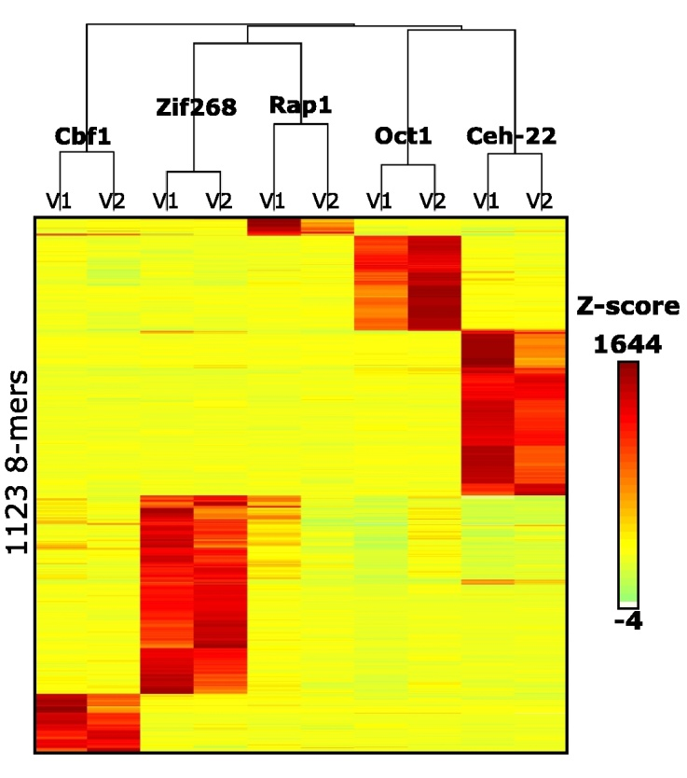
FIGURE 3.13 CLUSTERGRAM OF 8-MER Z-SCORE PROFILES DERIVED FROM BERGER ET AL. (2006) PBM DATA ILLUSTRATING THE DIFFERENT SUBSETS OF 8-MER SEQUENCES PREFEREABLY BOUND BY EACH TF. NOTE THAT THE REPLICATE PROFILES FOR EACH TF ARE MOST SIMILAR TO EACH OTHER.
the motifs from each motif-finding program and also collectively from all in a combined set, although a standard run would consist of only the combined set.

Figure 3.14 shows an of the motifs selected by MORE for the TF Oct-1, which contains a bipartite POU DBD that recognizes different sequences as a whole domain than its constituent subdomains (Verrijzer et al. 1992), POU-specific and POU-homeodomain. Kafal identified the POU-specific motif (C), the POU-Homeodomain motif (B/F) and the POU motif (A/E and D), while AlignACE found the POU-homeodomain motif, Bioprospector picked up the POU-specific motif and MEME returned the POU-homeodomain motif. The literature motif in Figure 3.14 is the POU motif. This example illustrates the value of running multiple-motif finders and using an approach like MORE, as only Kafal was able to identify all three motifs the bipartite POU-domain of Oct1 can bind while the rest of the motif-finders could only recover variations of one of the three. Furthermore, MORE can describe the relative contribution of each motif explaining the overall measured binding profile using the percent variance explained measure, showing for instance, that the motif returned by Bioprospector only accounts for 12% of the measured 8-mer binding profile variance, underscoring the utility of MORE in its ability to exhaustively sample motif-models and selecting the one(s) that are important.
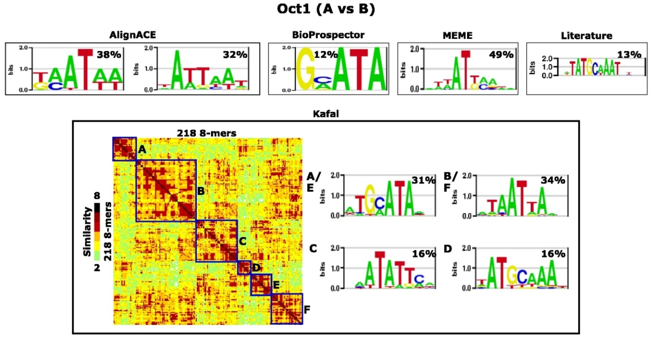
FIGURE 3.14 MULTIPLE, DISTINCT MOTIF MODELS CONTRIBUTE TO EXPLAINING THE EXPERIMENTAL BINDING DATA. THE A ARRAY REPLICATE 8-MER Z-SCORE PROFILE FOR THE TF OCT1 WAS USED TO DERIVE MOTIF-MODELS TESTED ON THE B ARRAY REPLICATE 8-MER Z-SCORE PROFILE. THE PERCENTAGE OF VARIANCE EXPLAINED BY EACH MOTIF ON THE B ARRAY PROFILE IS DEPICTED ALONGSIDE EACH MOTIF MODEL (AS IN FIGURE 3.11)
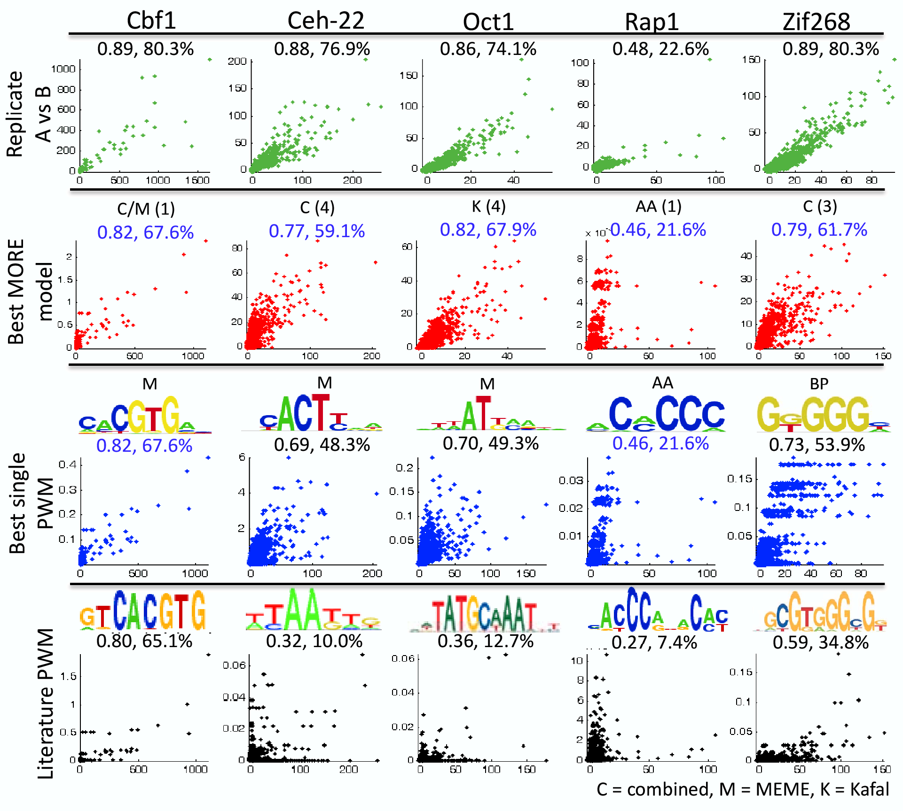
FIGURE 3.15 SCATTERPLOTS SHOWING THE REPLICATE ARRAY DATA AND PREDICTED Z-SCORES TRAINED ON PWMS (BEST SINGLE, COMBINATION AND LITERATURE) FROM ONE ARRAY REPLICATE VERSUS THE MEASURED Z-SCORES OF THE OTHER ARRAY REPLICATE. THE BEST PERFORMING EXAMPLE (EITHER ARRAY A VERSUS B OR VICE VERSA) WAS CHOSEN FOR EACH TF AS IN FIGURE 3.12.
Results as summarized in Figure 3.15 again show the MORE multiple-motif model performs as well and often better than the single best PWM. Exceptions are when MORE selects only one motif, usually for proteins whose binding activities are likely highly-specific and well described by just a single motif (Cbf1 and Rap1 in Figure 3.15).

In addition to percent variance explained and correlation measures, Dr. Lourdes Peña-Castillo and I added a third motif-finder evaluation measure we termed “top 100 overlap”, representing the overlap between the top 100 8-mers with the highest measured affinity for each TF and the top 100 8-mers as ranked by the predicted scores from the regression model for each set motifs derived from each motif-finder. The higher the top 100 8-mer overlap is between motif models trained on one replicate and measured affinities on the other replicate, the better its performance is deemed to be. Figure 3.16b shows a heatmap comparing the overlap between the top 100 8-mers between motif models and measured data, as well as the overlap of top 100 8-mers between each TF (Figure 3.16a shows this measure on the (Badis et al. 2008) data). Several observations are of note, one being the high reproducibility of overlap patterns between replicates, suggestive of the high similarity of motifs derived by each motif-finder for each replicate. Also of note is that in agreement with Table 3.1, AlignACE and MEME, along with the Agreement set (in A)/Combined set (in B) most frequently have the greatest top 100 overlap, next to data from the PBM replicate, supporting the idea that these motif-finders capture at least the dominate binding preferences quite well compared to the other tested motif-finders. Finally, the top 100 8-mer overlap between different TFs was almost always 0 or very low, demonstrating that the models capture the preferences specific to each TF. The lone exception is between Rap1 and Zif268, where a noisy experiment may have caused a small subset of 8-mers to overlap between the Rap1 and Zif268 experiments (evident in Figure 3.13). Lastly, it should also be noted that in comparisons between
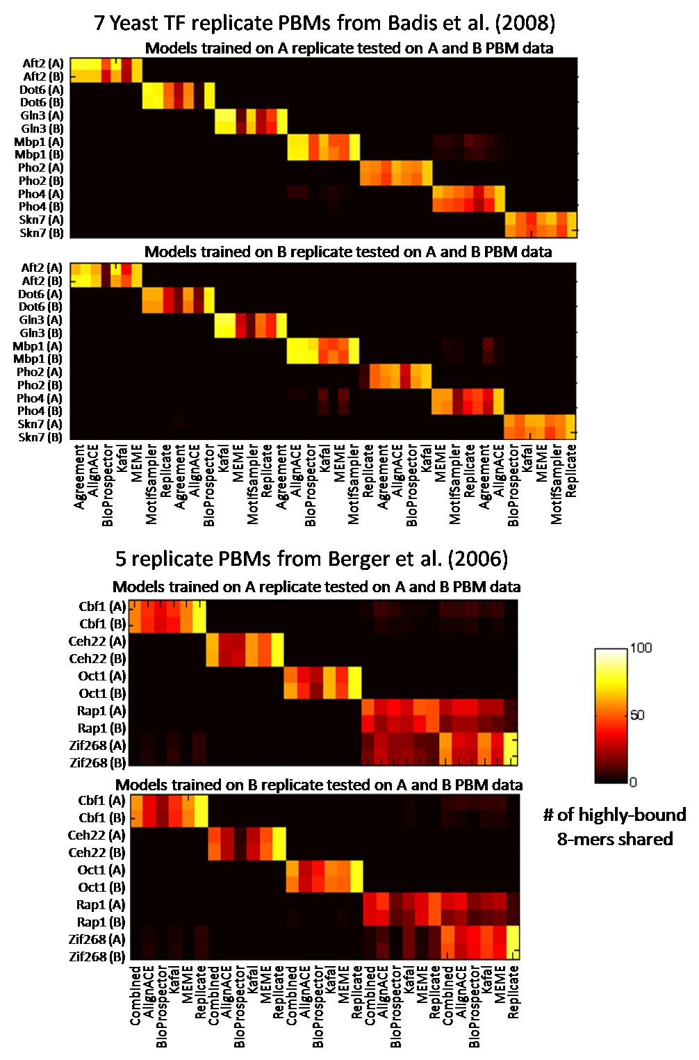
FIGURE 3.16 HEATMAPS SHOWING THE TOP 100 8-MER OVERLAP FOR EACH TF BETWEEN EACH MOTIF-MODEL LEARNED FROM ONE ARRAY AND TESTED ON THE TOP 100 8-MERS MEASURED ON A REPLICATE ARRAY AND VICE VERSA.

highly-related proteins, such as those belonging to the same structural family, a greater degree of common 8-mers between the top 100 8-mers for those related proteins would be expected. However, as demonstrated in our study of the homeodomains (Berger et al. 2008), even members of the same family have subtle differences in their binding preferences that become apparent when a sensitive and comprehensive assay like the PBM is used to assay binding over the full range of k-mers. Distinct binding activities between homeodomain family members could be identified by their limited overlap between the top 100 8-mers.

Discussion
With this work, Dr. Lourdes Peña-Castillo and I have taken steps towards improving the current single PWM model for transcription factor sequenc-binding specificity representation by introducing a framework defined by the novel MORE method. MORE creates a composite motif and evaluates how well a motif model or a combination of motif models captures measured TF-DNA binding data.

We showed that the MORE framework can aid in quantifying the accuracy of PWMs derived from different motif-finders and these results can be used to make an informed choice when selecting motif models derived by different motif-finding algorithms. Although I discussed the MORE method with respect to PBM data, MORE is generally applicable to any experimental method that is able to quantitatively profile the binding specificities of TFs across a non-biased set of oligonucleotide sequences. Recently developed techniques such as cognate site identifier (CSI) (Warren et al. 2006), SELEX-SAGE (Roulet et al. 2002) and microfluidic techniques (Maerkl and Quake 2007) would be amenable to the MORE method. MORE is also independent of the motif-finding algorithm used; requiring only that the computation approach represents the motif models as PWMs. All in all, MORE allows quantitative assessment of the significance of each motif model and motif model combinations to yield a rich representation of transcription factor binding specificities afforded by technologies such as the PBM assay.

With a PBM data processing system in place and a method to derive and evaluate motif models, there is now an opportunity to examine the relationship between TF-binding preferences and genomic features at a large scale. In the following section, I discuss several lines of evidence we have to support the in vivo relevance of PBM-derived motifs, including their positional bias and enrichment within promoters/NFRs, enrichment within suspected regulatory regions (e.g. conserved sequences, CpG islands) and enrichment within regions bound in vivo by the same factor.

3.2.4 Many TFBSs display preferences in their positional distribution relative to transcription start sites
It is now generally known that the promoter region possesses some unique sequence properties relative to the rest of the genome. As discussed in the first chapter, regions with elevated G+C content and unmethylated CpGs known as CpG islands are predominantly found overlapping the majority of mammalian gene promoters, particularly of broadly-expressed genes (Schug et al. 2005). More specifically, local variation in base composition and other DNA structural features such as bendability and denaturing propensity values surrounding the transcription start site region have been shown to form effective signatures for discriminating core promoter sequences from non-core promoters (Florquin et al. 2005; Kanhere and Bansal 2005; Abeel et al. 2008). Aerts and colleagues (Aerts et al. 2004) described a dramatic change in A+T content relative to G+C content in the [-1000, +1000] flanking the TSS, from approximately a 10% difference at the extremes to a 20% difference at the TSS in the human, mouse, rat, fly and Fugu promoters they studied. These patterns also appeared to correlate with expression breadth, as more broadly-expressed genes had higher CpG content and greater difference between A+T and G+C frequencies. Using an updated catalogue of annotated promoter regions from a newer version of DBTSS (Suzuki et al. 2002), I confirmed these patterns by enumerating and plotting the base frequencies relative to the [-1000, +1000] region surrounding the TSS and examined the [-200, +50] region more closely. Figure 3.17 shows the base frequency distribution in the [-200, +50] region for human, mouse, zebrafish, Arabidopsis and red alga promoters. Aside from the previously described dramatic difference in A+T and G+C content within this region, I noted two other readily apparent trends. First, in each species except for the red alga, there is a spike in A+T content near -30, corresponding to the canonical location of the TATA box. Second, a sharp spike followed by a cleft is present at the TSS, corresponding to the location of the INR and together, it’s possible that these two features may serve as “guide posts” to direct the location and orientation for transcription initiation. Similar signatures were noted by Abeel and colleagues (Abeel et al. 2008) in their analysis of promoter structural features, finding these same
positions to denature more easily, even in promoters lacking the TATA motif, perhaps reflecting the need for local DNA denaturation to facilitate TBP binding prior to transcription initiation.

Other studies have instead examined the frequency and distribution of short TFBS-sized k-mers finding evidence for both enrichment and positional bias of particular k-mers relative to the TSS, under the assumption that important regulatory sequences residing within these regions should form distinguishing profiles uncommon elsewhere in the genome (FitzGerald et al. 2004; Marino-Ramirez et al. 2004; Xie et al. 2005; Bina et al. 2006; FitzGerald et al. 2006; Bellora et al. 2007; Tabach et al. 2007; Bina et al. 2009). Among the most commonly reported motifs are those GC-rich motifs associated with the Sp1 family of C2H2 zinc-finger proteins and NRF-1, a mitochondrial
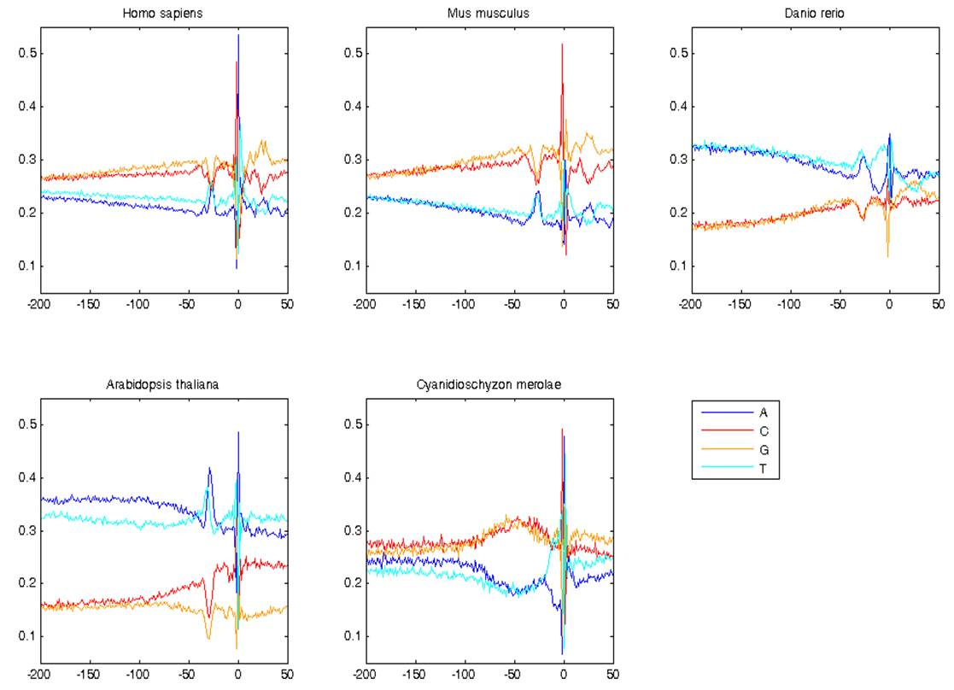
FIGURE 3.17 MONONUCLEOTIDE FREQUENCIES AROUND THE TSS [-200, +50] IN HUMAN, MOUSE, ZEBRAFISH, ARABIDOPSIS AND RED ALGA PROMOTERS

respiratory chain regulator, the cAMP response element (CRE) bound by Bzip proteins, as well as motifs bound by the ETS family of TFs (FitzGerald et al. 2004; Marino-Ramirez et al. 2004; Xie et al. 2005). However, making definitive associations between sequence motifs and the trans-acting factors that bind them is often challenging, usually relying on similarity matches to the limited motifs in repositories such as Transfac (Knuppel et al. 1994) and JASPAR (Sandelin et al. 2004); although recent ChIP-chip studies have also shown positional bias of binding near the TSS (Birney et al. 2007).

In this subsection, I describe how I used the comprehensive mouse TF-DBD PBM 8-mer affinity library to examine the frequency and distribution of highly-preferred 8-mer sequences for 216 different TFs within the proximal promoter region of yeast and mouse genes. The advantage with using the PBM-derived ranked lists of 8-mer affinities of course is that motifs can be unambiguously associated with the TFs known to bind them in vitro.

Given the diversity of the TFs within our PBM dataset, I sought to explore the distribution and prevalence of sequences preferably bound by those sequence-specific TFs relative to known TSSs. Starting with our yeast (Saccharomyces cerevisiae) PBM dataset and defining the 600 bases upstream of each ORF as the promoter region, I scanned for matches to each of the 112 PBM-derived PWM motifs (using the cutoff scores found here: http://hugheslab.ccbr.utoronto.ca/ supplementary-data/yeastDBD/PWM_cutoffs_yeastDBDs.xls). Figure 3.18 shows the presence of bias in the position of TF binding sequences in 5,015 yeast promoters with a well-defined TSS (Lee et al. 2007), corresponding to the NFR (approximately -130 to -50 relative to the TSS). Enrichment within this region include the sequences preferred by the Gal4 class of TFs, which were captured in our experiments primarily as monomers, as well as sequences preferred by TFs whose binding activity has not been previously described. Further lending support to the in vivo relevance of these motifs, in 27 out of the 112 motifs, GO term enrichment analysis (using Biological Process terms) found significant enrichment for at least one category amongst the top 100 promoter/motif combinations, such as Ste12 (Sterile 12) with “cell-cell fusion” (p < 2.2 x 10⁻¹⁴) and Pdr1 (Pleiotropic Drug Resistance) with “response to drug” (p < 1 x 10⁻⁶). Of particular note were two Gal4-class TF- like proteins of the RSC chromatin remodelling complex, Rsc3 and Rsc3, both favouring sequences containing CGCG, which are 16-fold more likely to occur within the NFR than within genes. This observation led us to propose a role for Rsc3 in the establishment and/or maintenance of the NFR like other TFs such as Abf1 and Reb1 (Lee et al. 2007) which Kyle Tsui, a graduate student in Dr. Corey Nislow’s lab at the University of Toronto subsequently confirmed experimentally when he
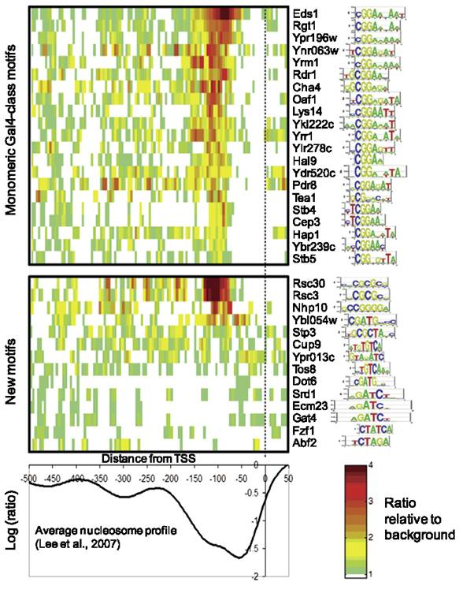
FIGURE 3.18 BIAS IN THE POSITION OF TF BINDING SEQUENCES WITHIN 5,015 PROMOTERS WITH A WELL-DEFINED TSS (LEE ET AL, 2007). MOTIF SCORES (GRANEK AND CLARKE, 2005) WERE CALCULATED FOR 8 BP WINDOWS, AND HIGH SCORING 8-MERS WERE TALLIED ALONG EQUIVALENT POSITIONS OF ALL THE YEAST PROMOTER SEQEUNCES USING A CUTOFF SELECTED TO CAPTURE ONLY THE LINEAR RANGE OF 8-MER BINDING Z-SCORE VERSUS PWM SCORE IN PBM EXPERIMENTS. BACKGROUND WAS CALCULATED FROM THE FIRST 100 BASES OF YEAST ORFS. TFS ARE SORTED BY RELATIVE ENRICHMENT BETWEEN -125 and -75.

observed a dramatic increase in nucleosome occupancy specifically in promoters containing a Rsc3 binding sequence when RSC3 was mutated (Badis et al. 2008).

Next, to examine the distribution of sequences preferred by the 104 mouse TF set taken from our PBM library in mouse promoters, I compiled a set of 21,095 mouse promoter sequences each spanning the [-1000, +200] region relative to the TSS from DBTSS (Suzuki et al. 2002), accessed on October 5, 2007. Although the use of multiple TSSs appears to be prevalent within core promoters of most genes (Carninci et al. 2006; Frith et al. 2008), the TSSs used in this analysis was selected as the most representative (most frequent and most upstream) according to the criteria used by the DBTSS (Suzuki et al. 2002). Within this set of sequences, I formed subsets differentiated into CpG island-containing (2,858) and non-CpG island-containing (1,733) promoters based on the work by Yamashita and colleagues (Yamashita et al. 2005). Two sets of control sequences (21,095) were also assembled, one based on randomly selecting length-matched sequences within the mouse (mm8 build) genome and another, using a 1st-order Markov model to match the dinucleotide content of each overlapping 8-mer window in the real promoter sequences, with a step size of 1. Next, for each TF, a list of “moderate” to “high” affinity 8-mers were selected based on a 0.4 E-score threshold to enumerate across each sequence set. Table 3.2 lists the TFs and the number of high affinity 8-mers under study. Each sequence in each set was scanned in overlapping 8-base windows, stepping 1 base at a time and 8-mers matching the high affinity set for each TF was tabulated and its location relative to the TSS was recorded. The frequency of occurrences of preferred 8-mers for each TF within each sequence set was then plotted relative to its location to the TSS.

In this analysis, I found that most TFs show distinct positional bias relative to the TSS. As expected, the profile for TBP is characterized by a sharp peak at -30, where the TATA box is usually found. Moreover, sequences highly preferred by TBP were found in about 5% of the entire promoter sequence set and found in over 10% of CpG promoters, consistent with previous findings that most promoters lack a TATA-box (Gershenzon and Ioshikhes 2005). The importance of TBP binding sequences at -30 is supported the presence of a stronger peak in real promoter sequences relative to random or shuffled genomic sequences.

Thorough examination of the promoter signatures over all 104 TFs revealed several striking examples of strong positional preference: for example, the frequency of E2F2 and E2F3 binding sequences near the TSS are roughly two orders of magnitude higher than at random genomic locations, in agreement with observed ChIP-chip data (Birney et al. 2007). Other examples include bZIP members Atf1 and Jundm2; ETS members Ehf, Gabpa, Sfpi and Spdef; HMG members Tcf7 and Tcf7l2 and C2H2 ZnFs Bcl6, Klf7, Osr1, Osr2, Zbtb3 (Figure 3.19). More generally, the TF position preference signatures reflect the unique base content distribution within the promoter region; with the G+C content rising towards the TSS, dipping at -30 at the TATA box and the A+T content showing the opposite trend (Aerts et al. 2004). The positional bias of highly-preferred 8-mer sequences for many of the tested TFs belonging to various structural classes relative to the TSS also suggests that these non-GTF proteins may have a broader role than previously appreciated at promoter regions as noted by others (Birney et al. 2007). It is tempting to speculate that these patterns of distinctive mono- and dinucleotide content may mark proximal promoters and TSSs by dramatically increasing the likelihood of binding by a variety of TFs, possibly with the apparent asymmetries with respect to TSS serving as positional markers to orient the direction of transcription.

Given that TFs are thought to bind in clusters and perhaps in a cooperative manner, it would be of interest to see if particular motif combinations in our dataset are found more frequently together than by chance and whether they are positionally-biased relative to the TSS. There is evidence for at least two classes of promoters defined by different patterns of TRANSFAC motif (Knuppel et al. 1994) co-occurrences in human promoters, with one class possessing a single peak near the TSS and the other associated with housekeeping genes and a broad distribution relative to the TSS genes (Murakami et al. 2008). Combinations of motif co-occurrences and co-absences have also been shown to be strongly associated with particular gene expression patterns, such as the

FIGURE 3.19 EXAMPLES OF TFS SHOWING EXCEPTIONAL PATTERNS OF POSITIONAL BIAS RELATIVE IN THE [-500 100] RELATIVE TO THE TSS.
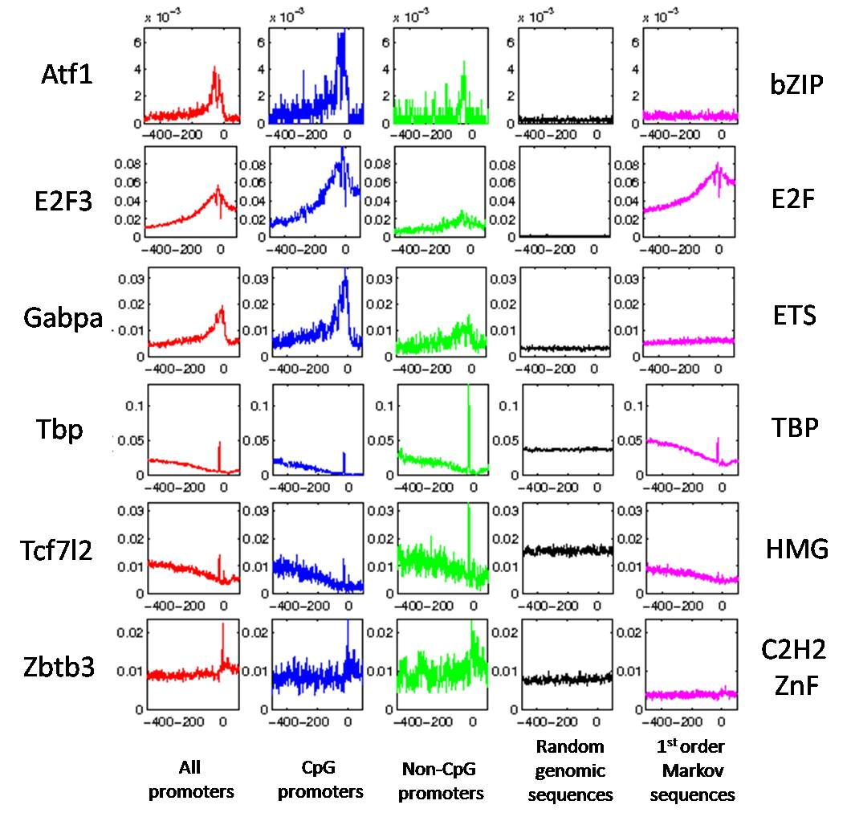
RRPE and PAC motifs with rRNA processing in yeast (Sudarsanam et al. 2002; Beer and Tavazoie 2004; Elemento et al. 2007) and these features, along with distance from the TSS and motif
orientation are informative of gene expression output (Beer and Tavazoie 2004; Elemento et al. 2007). Hence, using the PBM-derived motif library to learn combinations of motif features predictive of gene expression patterns should be a main priority for future studies.

3.2.5 Evidence for functional roles of PBM-derived putative TFBSs enriched within highly conserved, putative neuronal regulatory regions
Following the evidence I found supporting the functional relevance of PBM-derived TF binding 8-mers based on both their enrichment within promoters in a positionally-biased manner relative to the TSS and enrichment within genes with similar function, I reasoned that they would be enriched within highly-conserved sequence, if they are indeed of biological importance and if we have a sufficient sampling of putative TFBSs.
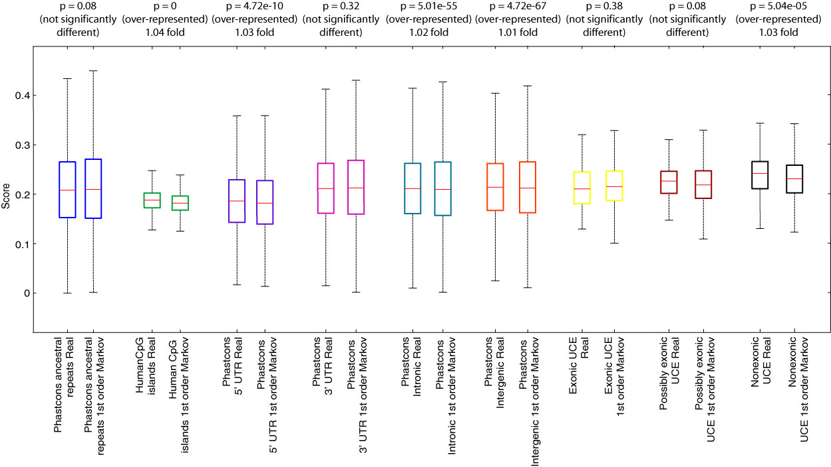
FIGURE 3.20 ENRICHMENT OF TF BINDING SITE 8-MERS BOUND AT E ≥ 0.40 AT VARIOUS GENOMIC REGIONS.

To test this hypothesis, I compiled a set of putative regulatory regions within the mouse genome by selecting evolutionarily conserved sequences overlapping particular genomic features, including UTRs, intergenic and intronic regions, non-exonic UCEs as well as CpG islands. I then asked whether 8-mers bound strongly in the in vitro PBM assays by any of the 104 mouse TFs (Badis et al. 2009) were enriched within this sequence set, considering conserved ancestral repeats as a negative control. Using several levels of stringency in defining the strength of binding from E-scores of 0.40, 0.43 and 0.45 or greater, 8-mers satisfying these cutoffs by any of the 104 TFs were assayed for their enrichment or depletion relative to matched (length and number) sequences with the same dinucleotide content as generated by a first-order Markov model. Figure 3.20 shows that overall, the enrichment or depletion of TF-binding 8-mer occurrences within these regions was quite minor, with enrichment of these 8-mers in noncoding regulatory regions in general (P < 10-9, Wilcoxon-Mann-Whitney test) and depletion in UTRs (P < 10-9) and ancestral repeats (P < 10-12)). Although the p-values are significant, I acknowledge that they may be in exact due to the strong overlapping 8-mers within these sequences to not necessarily by independent.

I also found CpG islands to be particularly enriched for binding sites for E2F (1.12-fold at E ≥ 0.40) and ETS (1.26-fold at E ≥ 0.40) proteins (Figure 3.21a). This finding is in agreement with ChIP-chip studies involving E2F family members in normal and tumour cell lines, where it was found that most E2F1, E2F4 and E2F6 binding sites were within 2kb of TSSs in vivo where CpG dinucleotides are enriched (Xu et al. 2007) and differential response to different E2F sequence elements by E2F proteins has been shown to be associated with CpG methylation status (Campanero et al. 2000).

Next, I considered non-exonic UCEs; finding “high” affinity 8-mer (E-score ≥ 0.45) for homeodomain (P < 10⁻²²) and BRIGHT (P < 10⁻¹²) proteins to have the greatest fold enrichment and is consistent with matches to a generalized homeodomain motif find within sequences overlapping UCEs as reported by others (Bailey et al. 2006; Chiang et al. 2008). In vivo assays testing for UCE enhancer activity found many to drive tissue-specific gene expression, particularly within the mouse
embryonic nervous system (Pennacchio et al. 2006; Visel et al. 2008) and preferential association with genes involved in regulation of transcription, development and nervous system development was also observed (Visel et al. 2008). Based on these observations, homeodomain and BRIGHT class

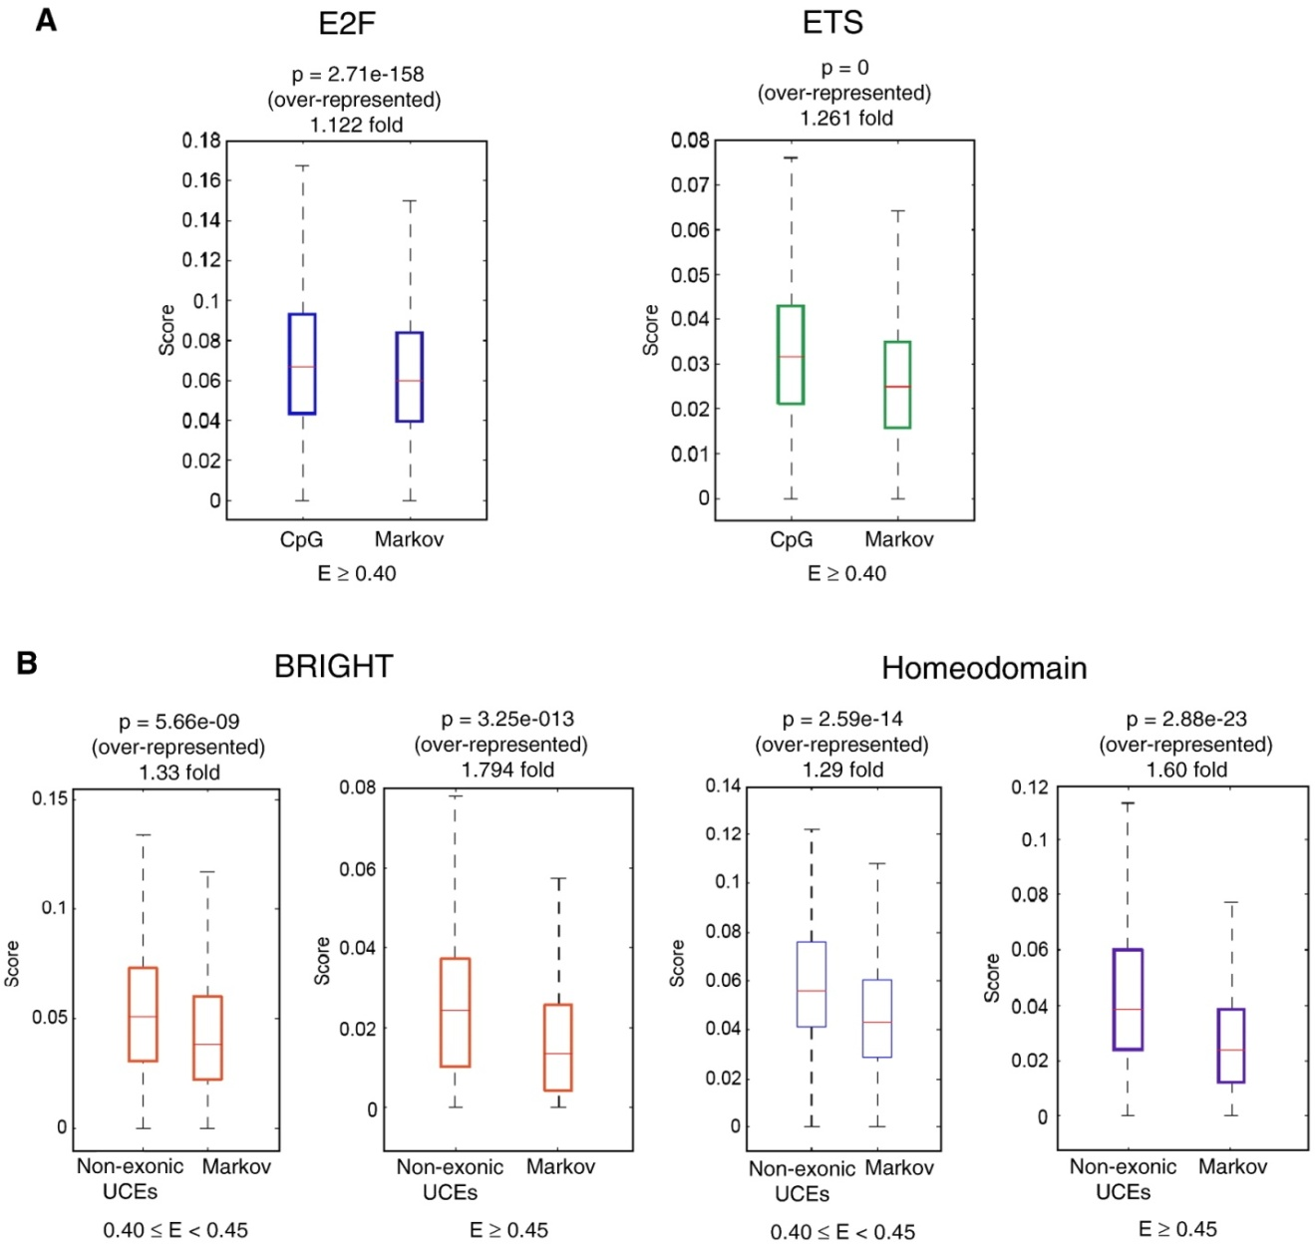
FIGURE 3.21 ENRICHMENT OF 8-MERS PREFERRED BY PARTICULAR TFS WITHIN PUTATIVE REGULATORY REGIONS. (A) CPG ISLANDS ARE ENRICHED FOR PBM “BOUND” 8-MERS FOR E2F AND ETS MEMBERS. (B) “MODERATE” (0.40 ≤ E < 0.45) AND “HIGH” (E ≥ 0.45) AFFINITY 8-MERS FOR TFS IN THE BRIGHT AND HOMEODOMAIN CLASSES ARE ENRICHED WITHIN NON-EXONIC UCES AS COMPARED TO SHUFFLED SEQUENCES WITH THE SAME DINUCELOTIDE CONTENT.

TFs (Figure 3.21b) may bind to UCEs to fine-tune the transcriptional regulatory state of cells during development and differentiation.
To explore this hypothesis and to examine the whether PBM “bound” 8-mers in UCEs have in vivo regulatory relevance, I collected experimentally-verified enhancer sequences (including UCEs) from the VISTA enhancer browser (http://enhancer.lbl.gov) in order to determine whether the corresponding TFs are expressed in the same tissue(s). For instance, Hox genes have been shown to be involved in controlling motor neuron identity (Guthrie 2007) and consistent with this observation, I found Hoxa3 PBM “bound” 8-mers (E ≥ 0.45) to be enriched within UCEs and highly conserved regions driving expression in the cranial nerve, hindbrain, midbrain, heart, limbs, neural tube, trigeminal nerve and dorsal root ganglion relative to the 1st-order Markov control sequences (P < 1.2 x 10⁻⁵, Fisher’s Exact test) (see methods in 3.2.6).

My colleague Dr. Rolf Stottmann at the Harvard Medical School extended this analysis to systematically search for correlations between TF and UCE-driven gene expression by studying the expression patterns of all 104 TFs within the mouse embryonic brain collected from in situ hybridization studies (Gray et al. 2004; Lein et al. 2007) and expression information available at the Mouse Genome Informatics database (MGI) (http://www.informatics.jax.org). Associations between PBM “bound” 8-mers (E ≥ 0.45) enriched within UCEs and highly-constrained genomic sequences (Pennacchio et al. 2006) with tissue-specific enhancer activity and many of the 104 TFs were identified by virtue of finding the TFs expressed within the same tissues; including for instance, Gata3 and enhancers enriched for its “bound” 8-mers were found to be both expressed in the eye lens and eye at E10.5 (Gray et al. 2004) and E11.5 respectively (P < 0.05, Fisher's Exact test) (Figure 3.22). Based on this analysis, we have found evidence for functional roles of PBM “bound” 8-mers enriched within highly conserved, putative neuronal regulatory regions. Other examples and the details on the full analysis are discussed elsewhere (Jaeger et al. 2010).
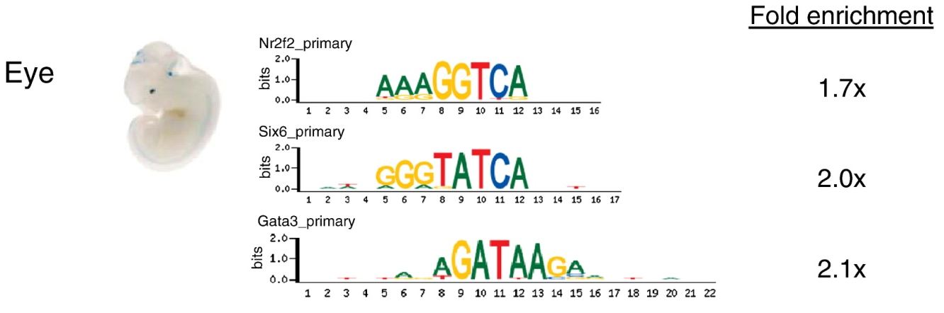

FIGURE 3.22 TFS EXPRESSED IN THE SAME TISSUES AS UCES ENRICHED FOR TF HIGHLY-PREFERRED 8-MERS. TF SEQUENCE LOGOS ARE PRESENTED FOR GRAPHIC CONVENIENCE: BINDING SEQUENCE ENRINCHMENT ANALYSIS WAS BASED ON PBM 8-MER DATA. FOLD-ENRICHMENT OF PREFERRED 8-MERS (E ≥ 0.45) WITHIN UCES IS CALCULATED AS COMPARED TO A CONTROL SET OF SHUFFLED UCE SEQUENCES WITH THE SAME DINUCLEOTIDE CONTENT 10 TIMES LARGER.

3.2.6 In vitro binding preferences are likely biologically relevant as preferred 8-mers are enriched in binding sites identified by in vivo methods
My next objective was to explore the in vivo usage of the PBM-derived motifs by considering their TF occupancy. Although we already have some evidence that high affinity 8-mers in vitro are preferentially found in sites bound in vivo from Dr. Lourdes Peña-Castillo’s analysis of the homedomains (Berger et al. 2008), we sought to test the general applicability for other structural classes, and particularly for those with secondary motifs. To do this, I first collected the available raw ChIP-chip or ChIP-seq datasets for TFs that preferably bound two distinct sets of sequences (secondary motifs) compiled from the literature by Dr. Gwenael Badis, listed in Table 3.3. These six ChIP-chip or ChIP-seq data sets involve immunoprecipitation of the same TFs or TFs with identical DBDs as the ones we analyzed.

Gene name | Gene alias | ChIP-chip/Chip-seq data
Bcl6 | BAZF | Ranuncolo et al. Nat Immunol 2007 Jul;8(7):705-14. PMID: 17558410, GEO accession: GSE7673
Hnf4a | HNF-4, Hnf4, HNF4 alpha, Hnf4g, MODY1, Nr2a1, Nuclear receptor 2A1, Tcf14, Tcf4 | Nielsen et al. unpublished. GEO accession: GSE7745
Myb | c-myb, v-myb, myeloblastosis oncogene, Mybl1, Mybl2, A-Myb, B-myb | Georlette et al. Genes Dev 2007 Nov 15;21(22):2880-96. PMID: 17978103, GEO accession: GSE9087
Nkx3-1 | bagpipe, Bax, Nkx-3.1, NKX3.1, NKX3A, Nkx2-1, Nkx2-4, Nkx2-2, Nkx2-9, Nkx2-3, Nkx2-5, Nkx2-6, Nkx3-1 | Jakobsen et al. Genes Dev 2007 Oct 1;21(19):2448-60. PMID: 17908931, ArrayExpress ID: E-TABM-247
Sox21 | Sox25, Sox2, Sox3 | Chen et al. Cell 2008 Jun 13;133(6):1106-17. PMID: 18555785, GEO accession: GSE11431
Srf | N/A | Cooper et al. Genome Res 2007 Feb;17(2):136-44. PMID: 17200232, GEO accession: GSE5998

TABLE 3.3 LIST OF TFS WITH SECONDARY MOTIFS FOR WHICH CHIP-CHIP DATA WAS AVAILABLE FOR ANALYSIS.
In all cases, I observed an enrichment of primary and/or secondary motifs nearby regions bound in vivo, peaking at or near the center (Figure 3.23). For two of these TFs, the regions bound by Hnf4a and Bcl6 were enriched for matches to 8-mers corresponding to the primary motif as well as the secondary motif, with the greatest enrichment toward the centres of the bound region (Figures 3.24a and b). Hnf4a secondary motif 8-mers are enriched even among those Hnf4a-bound
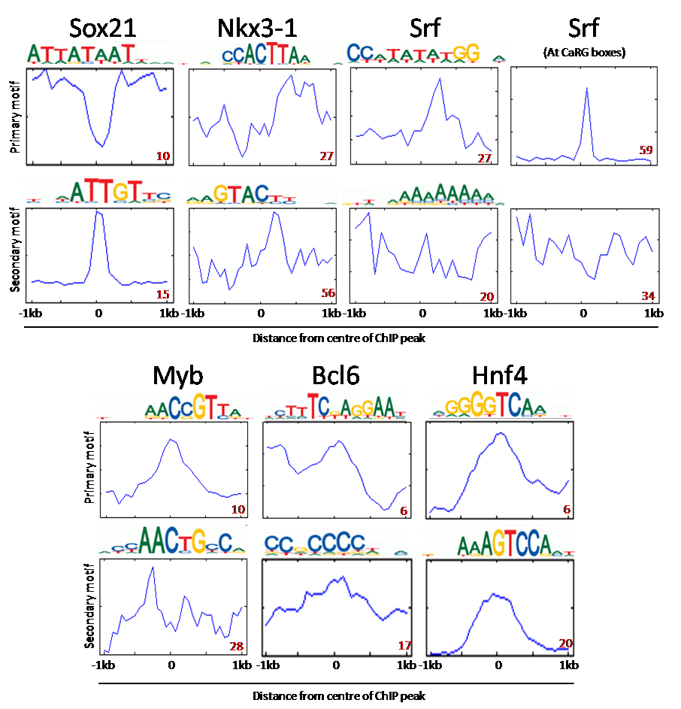
FIGURE 3.23 RELATIVE ENRICHMENT OF K-MERS CORRESPONDING TO PRIMARY VERSUS SECONDAY SEED-AND-WOBBLE MOTIFS WITHIN BOUND GENOMIC REGIONS IN CHIP-CHIP DATA AS COMPARED TO RANDOMLY-SELECTED GENOMIC SEQUENCES. SEE SECTION 3.4.7FOR METHODS. CHIP-CHIP DATA SOURCES AND GEO ACCESSION NUMBERS ARE AS FOUND IN TABLE 3.2. NUMBERS IN RED INDICATE NUMBER OF 8-MERS AT THE SCORE THRESHOLD SCANNED. SEED-AND-WOBBLE PRIMARY AND SECONDARY SEQUENCE LOGOS ARE SHOWN ABOVE EACH PLOT. SCAN FOR K-MERS IN THE SRF CHIP-CHIP DATA IS ADDITIONALLY SHOWN AT KNOWN CARG BOXES AS DEFINED BY COOPER ET AL. (2007).

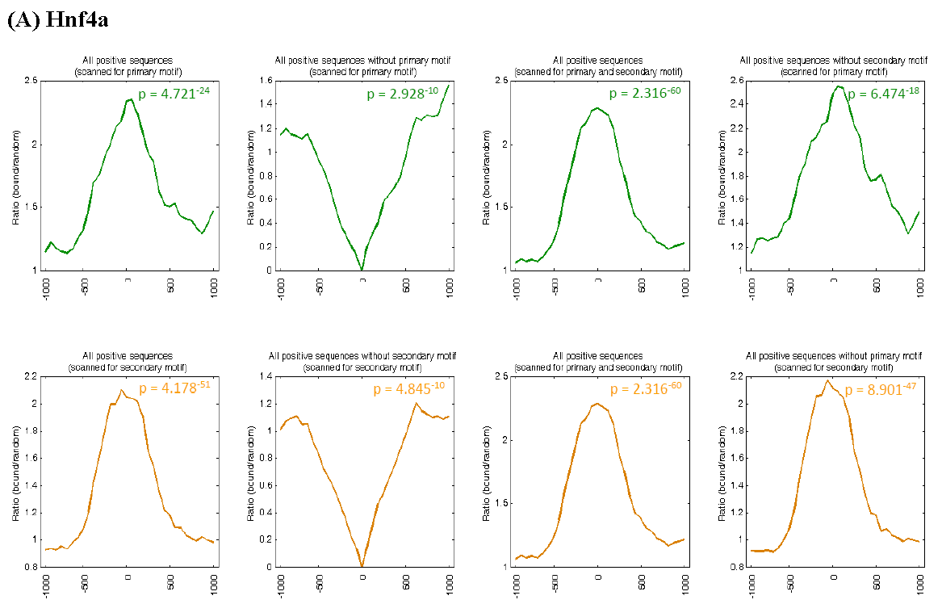
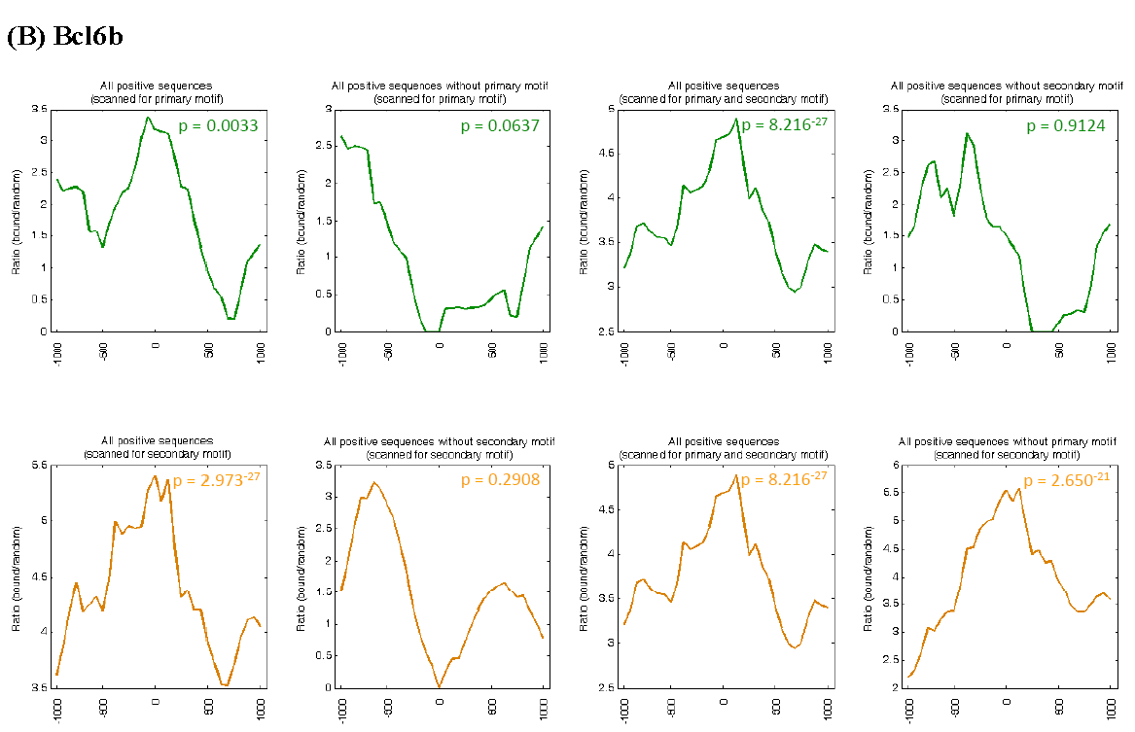
FIGURE 3.24 RELATIVE ENRICHMENT OF K-MERS CORRESPONDING TO THE PRIMARY VERSUS SECONDAY SEED-AND-WOBBLE MOTIFS WITHIN BOUND GENOMIC REGIONS IN CHIP-CHIP DATA AS COMPARED TO RANDOMLY SELECTED GENOMIC SEQUENCES WAS CALCULATED FOR (A) HNFA (GEO ACCESSION #GSE7745) AND (B) BCL6 (GEO ACCESSION #GSE7673). SEE SECTION 3.4.7 FOR METHODS. GOMER SCORE THRESHOLDS USED IN (A) ARE 2.958 X 10⁻⁷ AND 8.419 X 10⁻⁷, CORRESPONDING TO 9 PRIMARY AND 20 SECONDARY 8-MERS SCANNED, WHILE THRESHOLDS IN (B) ARE 1.513 X 10⁻⁶ AND 3.294 X 10⁻⁷ CORRESPONDING TO 4 PRIMARY AND 17 SECONDARY 8-MERS SCANNED.
regions that lack primary motif 8-mers (Figure 3.24a), suggesting that the secondary motif can recruit Hnf4a to genomic loci independently of the primary motif. I observed similar results for Bcl6 as well (Figure 3.24b).

Curiously, the primary motif 8-mers of Sox21 (paralog of Sox2) appear to be depleted in the centre of Sox2 bound regions in ES-cells, while the secondary motif is enriched at the centre of the bound region (Figure 3.23). Sox2 and Sox21 belong to closely-related SoxB1 and SoxB2 groups respectively and are thought to bind the same target sequences, though Sox21 possesses a C-terminal repression domain instead of an activation domain like Sox2 (Wegner and Stolt 2005). Interestingly, the expression of Sox21 and Sox2 strongly overlap (Rex et al. 1997) and Sox21 acts to repress the stem-cell maintenance effects of the SoxB2 proteins (Wegner and Stolt 2005). It is therefore likely that Sox2 and Sox21 target the same set of genes (Sandberg et al. 2005) and repression of Sox2 effects may be occurring through competition of Sox21 binding via its secondary motif. Perhaps the primary binding mode of Sox21 allows it to participate in a different function but allows it to counteract the function of SoxB1 proteins to promote neurogenesis via an alternate binding mode by way of its secondary motif. In support of this hypothesis, the primary motif for Sox21 is depleted at sites bound by Sox2 and does not match the motif for Sox2 (Chen et al. 2008), while its secondary motif resembles that of Sox2 and is enriched at these same sites. However, it remains to be seen whether the repressor activity of Sox21 is related to the existence of alternate binding modes, as a prior study suggests that it is the C-terminal domain rather than the HMG DNA-binding domain that is responsible for the different activities of SoxB1 and SoxB2 proteins (Sandberg et al. 2005).

Overall, this analysis suggests that secondary motifs are prevalent amongst mouse TFs across 22 different structural classes but further experiments and analyses are required to determine whether different gene regulatory effects are achieved through the use of distinct different sequence motifs by the same TF in vivo.

3.3 Summary and discussion
Our application of PBM technology to characterize TFs from a wide variety of different structural classes has revealed a wide variety of DNA binding preferences and complexity both across and within classes. Supporting evidence for the in vivo relevance of PBM-“bound” 8-mers came from their positional bias relative to the TSS and enrichment within promoters/NFRs, enrichment within suspected regulatory regions (e.g. conserved sequences, CpG islands), enrichment within regions bound in vivo by the same factor and enrichment of GO functional categories amongst genes associated with those regions (refer to (Jaeger et al. 2010) for greater detail). We also described for the first time, the broad existence of secondary motifs and demonstrated their presence and enrichment within regions bound by TFs in vivo. I developed a regression-based approach to describe TF-binding preferences as a multiple-motif model, learning the weighted combinations of motifs that best describe the PBM measurements in an independent replicate. This procedure was then further extended by Dr. Lourdes Peña-Castillo and I to a generalized framework for evaluation of multiple motifs termed MORE (Multiple-motif regression-based evaluator) which we used to show that multiple motifs often describe TF binding affinities as well and often better than the best single motif.

The utility of the PBM assay for interrogating the sequence binding behaviours of TFs should be readily apparent; its universal sequence design makes it amenable for testing TFs from virtually any species. It can therefore be used to explore the evolution of TF binding specificities by probing the sequence binding preferences of orthologous TFs to assess the level of conservation in binding behaviours over time. In our analysis of the mouse homeodomains, Dr. Lourdes Peña-Castillo and Trevis Alleyne found the sequence specificity of another homeodomain with unknown specificities can be best predicted by the binding profile of its nearest-neighbour by protein sequence similarity (Berger et al. 2008). It was also noted in the same analysis that the repertoire of homeodomain sequences at the protein level is diverse within a single species, but highly similar and conserved between species, with no mismatches at any of the 15 DNA-contacting residues for most mouse homeodomains to their fly homologs. We reasoned based on this observation that the nearest-neighbour approach should be applicable to predict the binding profile of a TF from a different species, based on its protein sequence similarity to that of a homolog with known specificity. Indeed, the sequence-binding profile for the worm homeodomain Ceh-22, predicted based on its most similar mouse homeodomain Nkx2.5, was highly correlated to that of its profile as measured profile (Pearson r = 0.93), suggesting that TF binding specificities remain mostly invariant over large evolutionary distances (Berger et al. 2008). Extension of the nearest-neighbour approach to other DBD structural classes found it to be applicable in the prediction of binding specificities for TFs of unknown specificity for at least 13 other classes (Alleyne 2008). These observations imply that changes in TF binding specificity to our knowledge, do not appear to account for the absence of conserved non-exonic sequence associated with patterns of conserved gene expression across vertebrate tissues as discussed in Chapter 2. While there are other avenues for trans-regulatory evolution to consider, such as the swapping of TFs within regulatory circuits (Tsong et al. 2006; Martchenko et al. 2007; Hogues et al. 2008) while maintaining the same output, exploration of these possibilities generally require searching for corresponding changes in cis-regulatory circuits. Thus, the focus of the next chapter is on using a high-throughput FAIRE-seq aimed at narrowing down the non-coding sequence search space over which to find putative regulatory sequences and CRMs to those regions that are active in regulation in each tissue in each species, as earlier attempts (Chapter 2) to identify conserved sequences with regulatory potential have proven to be very difficult using comparative genomics due to binding site turnover and shuffling of sequences over evolutionary time. Applying this approach with comparative genomics would hopefully provide enough resolution for conventional CRM detection programs to identify putative regulatory sequences lying within open chromatin and allow for cross-species comparisons to examine cis-regulatory evolution.

3.4 Materials and methods

3.4.1 TF-DBD PBM data collection and processing
The methods and details for cloning and expression of TF DNA-binding domains and PBM design and assay procedures are described elsewhere (Berger et al. 2006; Mintseris and Eisen 2006; Badis et al. 2008; Berger et al. 2008; Badis et al. 2009). In general, the scanned PBMs were analyzed using GenePix (Molecular Devices, Sunnyvale, USA) or ImaGene software (BioDiscovery, El Segundo, USA) and the data converted into two types of scores representing the relative binding preference for each TF-DBD over each of the 32,896 8-mers (reverse-complements combined), although scanning and normalization procedures varied slightly between studies. Taking the Badis et al. (Badis et al. 2008) data as an example, I first took the median signal intensity across the array from the spots containing each 8-mer and expressed them as Z-scores. Second, I calculated enrichment scores (E-scores) for each 8-mer (Berger et al. 2006), representing their relative ability to predict the rank order of the 35-mer probe intensities. Next, I used a cross-validation regime in which highly-bound 35-mers and 8-mers for each experiment (defined by the Z-score at the inflection point in a descending sort list of Z-scores or 0.45 score cutoff for E-scores) were selected and input into a panel of motif finding tools (Hughes et al. 2000; Liu et al. 2001; Thijs et al. 2001; Waterston et al. 2002; Chen et al. 2007), for which GOMER (Granek and Clarke 2005) scores for all possible 8-mers and 35-mer probe sequences were calculated against all resultant motifs, and those with the highest correlation to the input data were retained.

3.4.2 Lasso analysis and multiple-motif model representations of PBM data
I used the least absolute shrinkage and selection operator (Lasso) algorithm (Tibshirani 1996), which learns the weighting of each PWM by linear regression to build weighted combinations of PWMs. The input independent variables to Lasso were the 8-mer GOMER scores (Granek and Clarke 2005), which is an estimate of the probability of transcription factor binding, derived from the PWMs learned from each array experiment and the dependent variables were the 8-mer Z-scores and E-scores. Lasso only weights the motifs that contribute to explaining the variance. I then used a bootstrap procedure to assess the stability of the learned weights by subsampling

3.4.3 Assessing the predictive power of different motif representations
Briefly, given a PWM model for a TF binding, a value for each 8-mer was calculated, using the GOMER scoring function (Granek and Clarke 2005), that measures the probability of transcription factor binding to any site in the genome. Similarly, the Lasso regression model outputs a predicted score for each 8-mer and these 8-mer scores were then used in precision-recall analysis. The precision at a fixed 70% recall was calculated for 100 bins representing class 1 from a minimum E-score value of 0.2 (all of the 8-mers with E-score < 0.2 were classified as class 0) or a minimum Z-score of 2 (all of the 8-mers with Z-score < 2 were classified as class 0), to the maximum E- or Z-score for each PBM experiment (thus, the bins were of varying sizes across the different TFs but of equal size within each TF). At each E-score or Z-score threshold (i.e., each point on the graph) the Precision (= True Positives / (True Positives + False Positives)) was determined for the value at which the Recall (= True Positives / (True Positives + False Negatives)) is 70%. Similarly, for the AUC analysis, the AUC statistics measuring the probability that an example from class 1 scores higher than an example from class 0 were calculated for 40 bins representing class 1 from a minimum of 10 top to a maximum of 10,000 top 8-mers (0.1 increment on a log10 scale), and the bottom 22,896 8-mers represent class 0. At each threshold (i.e., each point on the graph), the Sensitivity (= True Positives / (True Positives + False Negatives)) and 1-Specificity (= false positive rate = False Positives / (False Positives + True Negatives)) were calculated. Percent of variance explained was calculated by taking the square of the Pearson correlation between the GOMER (Granek and Clarke 2005) 8-mer probabilities, for individual PWMs learned from one array and the Z-scores of the second array or the 8-mer predicted scores, for the multi-PWM regression model learned from one array and the Z-scores of the second array. Percent variance explained was calculated against Z-scores since they do not suffer from compression at the score extremes unlike the E-score.

3.4.4 Regression-based multiple motif model evaluation (with Dr. Lourdes Peña-Castillo)
Deriving Kafal motif models
Kafal (k-mer affinity align) finds motif models by clustering DNA sequences using affinity propagation (Frey and Dueck 2007) and then aligning all sequences in each cluster found using Clustalw (Chenna et al. 2003) (Figure 3.25). The similarity measure used during clustering is a modified edit distance where insertions are highly penalized. During clustering, the following parameter values are set for affinity propagation: maximum number of iterations to 3000, the number of iterations required to converge to 20, and the damping factor to 0.99. Default values where used for ClustalW.
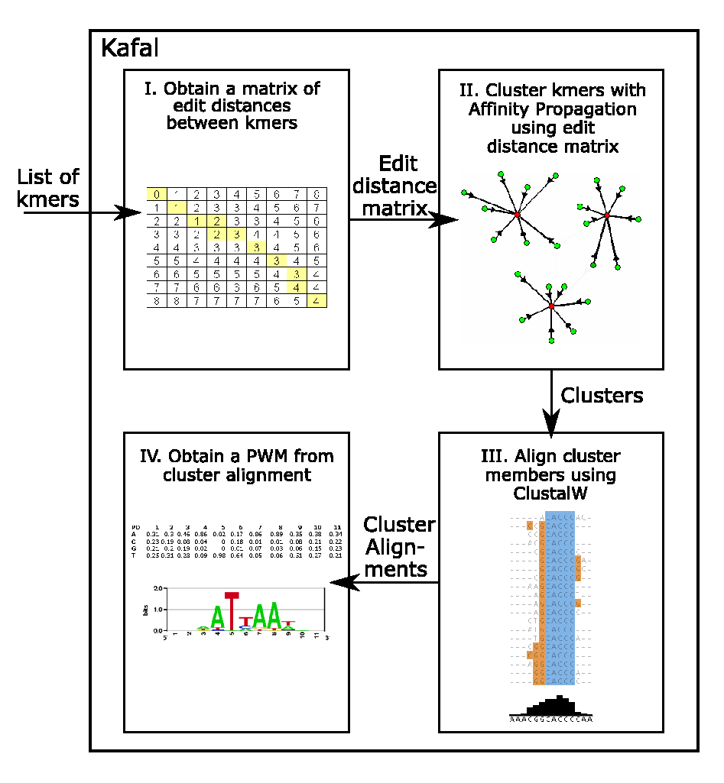
FIGURE 3.25 SCHEMATIC SHOWING HOW KAFAL FINDS MOTIFS USING K-MER DATA

Deriving AlignACE motif models
MEME (Waterston et al. 2002) was run to generate up to 40 motif models with a width between 5 to 14 and an E-value of less than 10. All other parameters were set to default. To allow the generation of motifs wider than 8 characters, the input sequences were first padded with width - 1 N characters on each side.

Deriving MEME motif models
AlignACE (Hughes et al. 2000) was recursively run to obtain motifs with a width between 5 and 14 (number of columns to align). The GC content of the input sequences was set to 0.5. All other input parameters were set to default. To obtain motifs with a width between 8 and 14, the input sequences were first padded with width - 1 N characters on each side. Dr. Lourdes Peña-Castillo used the aligned sequences obtained from AlignACE to compute the corresponding PWMs.

Deriving BioProspector motif models
BioProspector (Liu et al. 2001) was used to generate up to 40 candidate motifs with widths 5 to 14 inclusive. To ensure all possible positions could be aligned, the input sequences were first padded with width - 1 flanking N characters prior to input to the program. The input background distribution was derived from the input 8-mers. All other input parameters were set to the default.

Deriving MotifSampler motif models
MotifSampler (Thijs et al. 2001) was used to generate up to 40 candidate motifs with widths 5 to 14 inclusive. Since MotifSampler requires all characters in the input sequences to be A, C, G or T, when searching for motifs with widths between 8 and 14, we padded the input sequences with width - 1 flanking characters consisting of A, C, G and T at equal frequencies. The input background distribution was based on a zero-order Markov model derived from the probe sequences on the two independent microarray designs, as computed by the program CreateBackgroundModel (Thijs et al. 2001). All other input parameters were set to the default.

Redundancy removal using TomTom
MORE first filters out redundant motif models derived from multiple motif finders by doing all-versus-all pairwise similarity comparisons of each motif model derived from each PBM experiment using TomTom (Gupta et al. 2007). Highly similar motif models are reduced to a representative model by selecting the motif with the best score given by the originating motif finder or the longest motif among those with a TomTom similarity E-value smaller than 0.01.

Conversion of PWM representation into 8-mer profiles
MORE learns the combination of PWMs trained on one PBM replicate experiment that best predicts the 8-mer intensity data of the other PBM replicate. Each PWM is transformed into an 8-mer profile by calculating a score for each 8-mer using the GOMER (Granek and Clarke 2005) as described above. The 8-mer GOMER score profile is used by MORE’s linear regression scheme, which uses the least absolute shrinkage and selection operator (Lasso) method (Tibshirani 1996), to retain only those PWMs that are most informative in capturing the 8-mer binding intensity profiles.

Evaluation by cross-validation
In MORE’s evaluation step, the performance of PWMs trained on one array replicate is tested to explain the measured PBM intensity data from the other array replicate using cross-validation. For each PWM with a non-zero weight, the percentage of variance explained (Pearson r² value) was calculated between the model predicted z-score values of one replicate array and the measured z-scores of the other replicate array. Additionally, the loss in variance explained was calculated when each non-zero weight was zeroed. A PWM is considered to be selected by MORE if and only if the PWM was given a non-zero weight and had a Pearson r² value of at least 0.1.

Examining MORE’s performance
The stability of PWM weights output by MORE was assessed by bootstrapping. For each experiment, MORE was run on one thousand bootstrap pseudo-replicates and the 95% and 99% bootstrap confidence intervals were calculated. The stability of the MORE-weighted PWMs was also assessed by asking MORE to select the PWMs that best explain the measured binding data of one TF from the set of PWMs obtained for all TFs.

3.4.5 High-affinity 8-mer promoter and conserved sequence scans
Data collection and generation of control data sets
Human-based ultraconserved conserved sequences (Bejerano et al. 2004) and Phastcons syntenic conserved elements (Siepel et al. 2005) were downloaded from the authors’ supplementary websites (http://compgen.bscb.cornell.edu/~acs/conservation/ and http://users.soe.ucsc.edu/~jill/ ultra.html, respectively). Human CpG island sequences were downloaded from the CpG island track in the hg17 genome build using the UCSC table browser (Kuhn et al. 2009). Human, mouse, zebrafish and red alga promoter sequences were downloaded from DBTSS (Tsuritani et al. 2007). Control sequences with similar dinucleotide frequencies were generated using 1st order Markov models for every sequence within the data sets, using the program GenRGenS (Ponty et al. 2006). Two sets of control sequences were generated by: (1) selecting a length-matched set of random sequences across the mm8 build of the mouse genome, and (2) using a 1st and 2nd order Markov model to control for di- and tri-nucleotide frequencies in overlapping 8-mer windows with a step size of 1 bp. Yeast promoters were defined as 500 bp 5’ to the start of each ORF and background sequences were selected from within the ORFs.

Scanning of sequences genomic regions and promoters
Each sequence in each set of non-yeast genomic regions and control sequences was scanned in overlapping 8-mer windows with a step size of 1 bp using custom Perl scripts. The fraction of windows with matches to 8-mers with E-scores equal or greater than a threshold value for any TF or any TFs of a particular structural class for each sequence was plotted using MATLAB. Enrichment and statistical significance of scores in real versus control sequence sets were determined using the Wilcoxon-Mann-Whitney (WMW) test implemented in MATLAB.

Each non-yeast genomic sequence and the matching control sequences were scanned in overlapping 8-mer windows with a step size of 1 bp for hits against 8-mers with E ≥ 0.40 for each TF using custom Perl scripts. The distribution of the positive 8-mer hits relative to the TSS was plotted as a normalized fraction for each sequence set and each TF using MATLAB.

Yeast promoters were scanned in 8-mer windows using GOMER (Granek and Clarke 2005) to estimate the probability of binding for each yeast DBD along the promoters. High-scoring 8-mers were selected using a cutoff which captured only the linear range of 8-mer binding Z-scores versus PWM scores in PBM experiments and tallied across promoter window. PWM cutoff score values can be found in the supplementary data accompanying the Badis et al. 2008 publication: http://hugheslab.ccbr.utoronto.ca/supplementary-data/yeastDBD/PWM_cutoffs_yeastDBDs.xls.

3.4.6 Analysis of “High” affinity PBM-bound 8-mers within UCEs
UCEs and other predicted enhancer sequences highly conserved from human to pufferfish assayed for tissue-specific enhancer function (Pennacchio et al. 2006; Visel et al. 2008) were downloaded from the VISTA Enhancer browser website (http://enhancer.lbl.gov/). These sequences were classified as positives or negatives according to whether they drove expression in one or more of the following mouse embryonic tissues: branchial arch, cranial nerve, dorsal root ganglion, ear, eye, facial mesenchyme, forebrain genital tubercle, heart, hindbrain, limb, melanocytes, midbrain, neural crest mesenchyme, neural tube, nose, other, somite, tail, and trigeminal V. Enrichment of “high” affinity 8-mers within tested enhancer sequences for each TF and each set of enhancer sequences classified by the tissue expression is controlled in relative to shuffled enhancer sequence sets with the same dinucleotide content ten times larger, was determined using Fisher’s exact test.

3.4.7 Analysis of ChIP-chip data for presence of primary and secondary motifs
Relative enrichment of k-mers corresponding to the primary versus secondary Seed-and-Wobble motifs within bound genomic regions in ChIP-chip data as compared to randomly selected sequences was calculated for Bcl6 (Ranuncolo et al. 2007) (GEO accession: GSE7673) and for Hnf4a (Neilsen et al., submitted; GEO accession: GSE7745). ChIP-chip ‘bound’ peaks were identified according to the criteria of the respective studies ((Ranuncolo et al. 2007); Neilsen et al., submitted). Briefly, I extracted the sequences of the peaks such that if the peak location was not specified, then flanking sequence from the midpoints of positive probes (usually defined as the middle probe of a string of five consecutive positive probes) was extracted. Several different window sizes were used including 500 bp with a step size of 100 bp, 100 bp windows with a step size of 93 bp and 500 bp windows with a step size of 50 bp. Regions “bound” in vivo by ChIP-chip were split according to whether or not they had a primary or secondary 8-mer above the score threshold within the -250 to +250 windows considered in my analysis. This was done essentially as in a prior study (Berger et al. 2008), except that here, I used thresholds for 8-mers based on GOMER scores rather than on E-scores. This resulted in 4 types of regions: 1) those with only a primary motif 8-mer; 2) those with only a secondary motif 8-mer only; 3) those with both primary and secondary motif 8-mers; and 4) those with neither primary nor secondary motif 8-mers. 8-mer enrichment was calculated relative to a background sequence set containing ten times the number of randomly selected genomic regions. P-values were calculated for the interval (−250 to +250) by the WMW rank sum test, comparing the number of occurrences per sequence in the bound set versus the background set.

References
Abeel T, Saeys Y, Bonnet E, Rouze P, Van de Peer Y. 2008. Generic eukaryotic core promoter prediction using structural features of DNA. Genome research 18(2): 310-323.
Aerts S, Thijs G, Dabrowski M, Moreau Y, De Moor B. 2004. Comprehensive analysis of the base composition around the transcription start site in Metazoa. BMC genomics 5(1): 34.
Alleyne TM. 2008. Prediction of Transcription Factor DNA Sequence Specificity and its Determinants. University of Toronto, 2008.
Badis G, Berger MF, Philippakis AA, Talukder S, Gehrke AR, Jaeger SA, Chan ET, Metzler G, Vedenko A, Chen X et al. 2009. Diversity and complexity in DNA recognition by transcription factors. Science (New York, NY 324(5935): 1720-1723.
Badis G, Chan ET, van Bakel H, Pena-Castillo L, Tillo D, Tsui K, Carlson CD, Gossett AJ, Hasinoff MJ, Warren CL et al. 2008. A library of yeast transcription factor motifs reveals a widespread function for Rsc3 in targeting nucleosome exclusion at promoters. Molecular cell 32(6): 878-887.
Bailey PJ, Klos JM, Andersson E, Karlen M, Kallstrom M, Ponjavic J, Muhr J, Lenhard B, Sandelin A, Ericson J. 2006. A global genomic transcriptional code associated with CNS-expressed genes. Experimental cell research 312(16): 3108-3119.
Bailey TL, Elkan C. 1994. Fitting a mixture model by expectation maximization to discover motifs in biopolymers. Proceedings / International Conference on Intelligent Systems for Molecular Biology ; ISMB 2: 28-36.
Bailey TL, Noble WS. 2003. Searching for statistically significant regulatory modules. Bioinformatics 19 Suppl 2: ii16-25.
Beer MA, Tavazoie S. 2004. Predicting gene expression from sequence. Cell 117(2): 185-198.
Bejerano G, Pheasant M, Makunin I, Stephen S, Kent WJ, Mattick JS, Haussler D. 2004. Ultraconserved elements in the human genome. Science (New York, NY 304(5675): 1321-1325.
Bellora N, Farre D, Alba MM. 2007. Positional bias of general and tissue-specific regulatory motifs in mouse gene promoters. BMC genomics 8: 459.
Berger MF, Badis G, Gehrke AR, Talukder S, Philippakis AA, Pena-Castillo L, Alleyne TM, Mnaimneh S, Botvinnik OB, Chan ET et al. 2008. Variation in homeodomain DNA binding revealed by high-resolution analysis of sequence preferences. Cell 133(7): 1266-1276.
Berger MF, Philippakis AA, Qureshi AM, He FS, Estep PW, 3rd, Bulyk ML. 2006. Compact, universal DNA microarrays to comprehensively determine transcription-factor binding site specificities. Nature biotechnology 24(11): 1429-1435.
Bina M, Wyss P, Lazarus SA, Shah SR, Ren W, Szpankowski W, Crawford GE, Park SP, Song XC. 2009. Discovering sequences with potential regulatory characteristics. Genomics 93(4): 314-322.
Bina M, Wyss P, Shah SR. 2006. A database of 9-mers from promoter regions of human protein-coding genes. Methods in molecular biology (Clifton, NJ 338: 129-134.
Birney E Stamatoyannopoulos JA Dutta A Guigo R Gingeras TR Margulies EH Weng Z Snyder M Dermitzakis ET Thurman RE et al. 2007. Identification and analysis of functional elements in 1% of the human genome by the ENCODE pilot project. Nature 447(7146): 799-816.
Campanero MR, Armstrong MI, Flemington EK. 2000. CpG methylation as a mechanism for the regulation of E2F activity. Proceedings of the National Academy of Sciences of the United States of America 97(12): 6481-6486.
Carninci P, Sandelin A, Lenhard B, Katayama S, Shimokawa K, Ponjavic J, Semple CA, Taylor MS, Engstrom PG, Frith MC et al. 2006. Genome-wide analysis of mammalian promoter architecture and evolution. Nature genetics 38(6): 626-635.
Chen X, Hughes TR, Morris Q. 2007. RankMotif++: a motif-search algorithm that accounts for relative ranks of K-mers in binding transcription factors. Bioinformatics (Oxford, England) 23(13): i72-79.
Chen X, Xu H, Yuan P, Fang F, Huss M, Vega VB, Wong E, Orlov YL, Zhang W, Jiang J et al. 2008. Integration of external signaling pathways with the core transcriptional network in embryonic stem cells. Cell 133(6): 1106-1117.
Chenna R, Sugawara H, Koike T, Lopez R, Gibson TJ, Higgins DG, Thompson JD. 2003. Multiple sequence alignment with the Clustal series of programs. Nucleic acids research 31(13): 3497-3500.
Chiang CW, Derti A, Schwartz D, Chou MF, Hirschhorn JN, Wu CT. 2008. Ultraconserved elements: analyses of dosage sensitivity, motifs and boundaries. Genetics 180(4): 2277-2293.
Daignan-Fornier B, Fink GR. 1992. Coregulation of purine and histidine biosynthesis by the transcriptional activators BAS1 and BAS2. Proceedings of the National Academy of Sciences of the United States of America 89(15): 6746-6750.
Elemento O, Slonim N, Tavazoie S. 2007. A universal framework for regulatory element discovery across all genomes and data types. Molecular cell 28(2): 337-350.
FitzGerald PC, Shlyakhtenko A, Mir AA, Vinson C. 2004. Clustering of DNA sequences in human promoters. Genome research 14(8): 1562-1574.
FitzGerald PC, Sturgill D, Shyakhtenko A, Oliver B, Vinson C. 2006. Comparative genomics of Drosophila and human core promoters. Genome biology 7(7): R53.
Florquin K, Saeys Y, Degroeve S, Rouze P, Van de Peer Y. 2005. Large-scale structural analysis of the core promoter in mammalian and plant genomes. Nucleic Acids Res 33(13): 4255-4264.
Foat BC, Morozov AV, Bussemaker HJ. 2006. Statistical mechanical modeling of genome-wide transcription factor occupancy data by MatrixREDUCE. Bioinformatics (Oxford, England) 22(14): e141-149.
Frey BJ, Dueck D. 2007. Clustering by passing messages between data points. Science (New York, NY 315(5814): 972-976.
Frith MC, Valen E, Krogh A, Hayashizaki Y, Carninci P, Sandelin A. 2008. A code for transcription initiation in mammalian genomes. Genome research 18(1): 1-12.
Gershenzon NI, Ioshikhes IP. 2005. Synergy of human Pol II core promoter elements revealed by statistical sequence analysis. Bioinformatics 21(8): 1295-1300.
Granek JA, Clarke ND. 2005. Explicit equilibrium modeling of transcription-factor binding and gene regulation. Genome biology 6(10): R87.
Gray PA, Fu H, Luo P, Zhao Q, Yu J, Ferrari A, Tenzen T, Yuk DI, Tsung EF, Cai Z et al. 2004. Mouse brain organization revealed through direct genome-scale TF expression analysis. Science (New York, NY 306(5705): 2255-2257.
Gupta S, Stamatoyannopoulos JA, Bailey TL, Noble WS. 2007. Quantifying similarity between motifs. Genome biology 8(2): R24.
Guthrie S. 2007. Patterning and axon guidance of cranial motor neurons. Nature reviews 8(11): 859-871.
Hogues H, Lavoie H, Sellam A, Mangos M, Roemer T, Purisima E, Nantel A, Whiteway M. 2008. Transcription factor substitution during the evolution of fungal ribosome regulation. Molecular cell 29(5): 552-562.
Hughes JD, Estep PW, Tavazoie S, Church GM. 2000. Computational identification of cis-regulatory elements associated with groups of functionally related genes in Saccharomyces cerevisiae. Journal of molecular biology 296(5): 1205-1214.
Jaeger SA, Chan ET, Berger MF, Stottmann R, Hughes TR, Bulyk ML. 2010. Conservation and regulatory associations of a wide affinity range of mouse transcription factor binding sites. Genomics.
Kanhere A, Bansal M. 2005. Structural properties of promoters: similarities and differences between prokaryotes and eukaryotes. Nucleic Acids Res 33(10): 3165-3175.
Knuppel R, Dietze P, Lehnberg W, Frech K, Wingender E. 1994. TRANSFAC retrieval program: a network model database of eukaryotic transcription regulating sequences and proteins. J Comput Biol 1(3): 191-198.
Kuhn RM, Karolchik D, Zweig AS, Wang T, Smith KE, Rosenbloom KR, Rhead B, Raney BJ, Pohl A, Pheasant M et al. 2009. The UCSC Genome Browser Database: update 2009. Nucleic acids research 37(Database issue): D755-761.
Lee W, Tillo D, Bray N, Morse RH, Davis RW, Hughes TR, Nislow C. 2007. A high-resolution atlas of nucleosome occupancy in yeast. Nature genetics 39(10): 1235-1244.
Lein ES Hawrylycz MJ Ao N Ayres M Bensinger A Bernard A Boe AF Boguski MS Brockway KS Byrnes EJ et al. 2007. Genome-wide atlas of gene expression in the adult mouse brain. Nature 445(7124): 168-176.
Liu X, Brutlag DL, Liu JS. 2001. BioProspector: discovering conserved DNA motifs in upstream regulatory regions of co-expressed genes. Pacific Symposium on Biocomputing: 127-138.
MacIsaac KD, Wang T, Gordon DB, Gifford DK, Stormo GD, Fraenkel E. 2006. An improved map of conserved regulatory sites for Saccharomyces cerevisiae. BMC bioinformatics 7: 113.
Maerkl SJ, Quake SR. 2007. A systems approach to measuring the binding energy landscapes of transcription factors. Science (New York, NY 315(5809): 233-237.
Marino-Ramirez L, Spouge JL, Kanga GC, Landsman D. 2004. Statistical analysis of over-represented words in human promoter sequences. Nucleic Acids Res 32(3): 949-958.
Martchenko M, Levitin A, Hogues H, Nantel A, Whiteway M. 2007. Transcriptional rewiring of fungal galactose-metabolism circuitry. Curr Biol 17(12): 1007-1013.
Mintseris J, Eisen MB. 2006. Design of a combinatorial DNA microarray for protein-DNA interaction studies. BMC bioinformatics 7: 429.
Murakami K, Imanishi T, Gojobori T, Nakai K. 2008. Two different classes of co-occurring motif pairs found by a novel visualization method in human promoter regions. BMC genomics 9: 112.
Noyes MB, Christensen RG, Wakabayashi A, Stormo GD, Brodsky MH, Wolfe SA. 2008. Analysis of homeodomain specificities allows the family-wide prediction of preferred recognition sites. Cell 133(7): 1277-1289.
Pennacchio LA, Ahituv N, Moses AM, Prabhakar S, Nobrega MA, Shoukry M, Minovitsky S, Dubchak I, Holt A, Lewis KD et al. 2006. In vivo enhancer analysis of human conserved non-coding sequences. Nature 444(7118): 499-502.
Ponty Y, Termier M, Denise A. 2006. GenRGenS: software for generating random genomic sequences and structures. Bioinformatics (Oxford, England) 22(12): 1534-1535.
Ranuncolo SM, Polo JM, Dierov J, Singer M, Kuo T, Greally J, Green R, Carroll M, Melnick A. 2007. Bcl-6 mediates the germinal center B cell phenotype and lymphomagenesis through transcriptional repression of the DNA-damage sensor ATR. Nature immunology 8(7): 705-714.
Rex M, Uwanogho DA, Orme A, Scotting PJ, Sharpe PT. 1997. cSox21 exhibits a complex and dynamic pattern of transcription during embryonic development of the chick central nervous system. Mechanisms of development 66(1-2): 39-53.
Roulet E, Busso S, Camargo AA, Simpson AJ, Mermod N, Bucher P. 2002. High-throughput SELEX SAGE method for quantitative modeling of transcription-factor binding sites. Nature biotechnology 20(8): 831-835.
Sandberg M, Kallstrom M, Muhr J. 2005. Sox21 promotes the progression of vertebrate neurogenesis. Nature neuroscience 8(8): 995-1001.
Sandelin A, Alkema W, Engstrom P, Wasserman WW, Lenhard B. 2004. JASPAR: an open-access database for eukaryotic transcription factor binding profiles. Nucleic Acids Res 32(Database issue): D91-94.
Schug J, Schuller WP, Kappen C, Salbaum JM, Bucan M, Stoeckert CJ, Jr. 2005. Promoter features related to tissue specificity as measured by Shannon entropy. Genome biology 6(4): R33.
Siepel A, Bejerano G, Pedersen JS, Hinrichs AS, Hou M, Rosenbloom K, Clawson H, Spieth J, Hillier LW, Richards S et al. 2005. Evolutionarily conserved elements in vertebrate, insect, worm, and yeast genomes. Genome research 15(8): 1034-1050.
Sudarsanam P, Pilpel Y, Church GM. 2002. Genome-wide co-occurrence of promoter elements reveals a cis-regulatory cassette of rRNA transcription motifs in Saccharomyces cerevisiae. Genome research 12(11): 1723-1731.
Suzuki Y, Yamashita R, Nakai K, Sugano S. 2002. DBTSS: DataBase of human Transcriptional Start Sites and full-length cDNAs. Nucleic Acids Res 30(1): 328-331.
Tabach Y, Brosh R, Buganim Y, Reiner A, Zuk O, Yitzhaky A, Koudritsky M, Rotter V, Domany E. 2007. Wide-scale analysis of human functional transcription factor binding reveals a strong bias towards the transcription start site. PloS one 2(8): e807.
Tanay A. 2006. Extensive low-affinity transcriptional interactions in the yeast genome. Genome research 16(8): 962-972.
Thijs G, Lescot M, Marchal K, Rombauts S, De Moor B, Rouze P, Moreau Y. 2001. A higher-order background model improves the detection of promoter regulatory elements by Gibbs sampling. Bioinformatics (Oxford, England) 17(12): 1113-1122.
Tibshirani R. 1996. Regression Shrinkage and Selection via the Lasso. Journal of the Royal Statistical Society Series B (Methodological) 58(1): 267-288.
Tsong AE, Tuch BB, Li H, Johnson AD. 2006. Evolution of alternative transcriptional circuits with identical logic. Nature 443(7110): 415-420.
Tsuritani K, Irie T, Yamashita R, Sakakibara Y, Wakaguri H, Kanai A, Mizushima-Sugano J, Sugano S, Nakai K, Suzuki Y. 2007. Distinct class of putative "non-conserved" promoters in humans: comparative studies of alternative promoters of human and mouse genes. Genome research 17(7): 1005-1014.
Verrijzer CP, Alkema MJ, van Weperen WW, Van Leeuwen HC, Strating MJ, van der Vliet PC. 1992. The DNA binding specificity of the bipartite POU domain and its subdomains. Embo J 11(13): 4993-5003.
Visel A, Prabhakar S, Akiyama JA, Shoukry M, Lewis KD, Holt A, Plajzer-Frick I, Afzal V, Rubin EM, Pennacchio LA. 2008. Ultraconservation identifies a small subset of extremely constrained developmental enhancers. Nature genetics 40(2): 158-160.
Warren CL, Kratochvil NC, Hauschild KE, Foister S, Brezinski ML, Dervan PB, Phillips GN, Jr., Ansari AZ. 2006. Defining the sequence-recognition profile of DNA-binding molecules. Proceedings of the National Academy of Sciences of the United States of America 103(4): 867-872.
Waterston RH Lindblad-Toh K Birney E Rogers J Abril JF Agarwal P Agarwala R Ainscough R Alexandersson M An P et al. 2002. Initial sequencing and comparative analysis of the mouse genome. Nature 420(6915): 520-562.
Wegner M, Stolt CC. 2005. From stem cells to neurons and glia: a Soxist's view of neural development. Trends in neurosciences 28(11): 583-588.
Xie X, Lu J, Kulbokas EJ, Golub TR, Mootha V, Lindblad-Toh K, Lander ES, Kellis M. 2005. Systematic discovery of regulatory motifs in human promoters and 3' UTRs by comparison of several mammals. Nature 434(7031): 338-345.
Xu X, Bieda M, Jin VX, Rabinovich A, Oberley MJ, Green R, Farnham PJ. 2007. A comprehensive ChIP-chip analysis of E2F1, E2F4, and E2F6 in normal and tumor cells reveals interchangeable roles of E2F family members. Genome research 17(11): 1550-1561.
Yamashita R, Suzuki Y, Sugano S, Nakai K. 2005. Genome-wide analysis reveals strong correlation between CpG islands with nearby transcription start sites of genes and their tissue specificity. Gene 350(2): 129-136.

